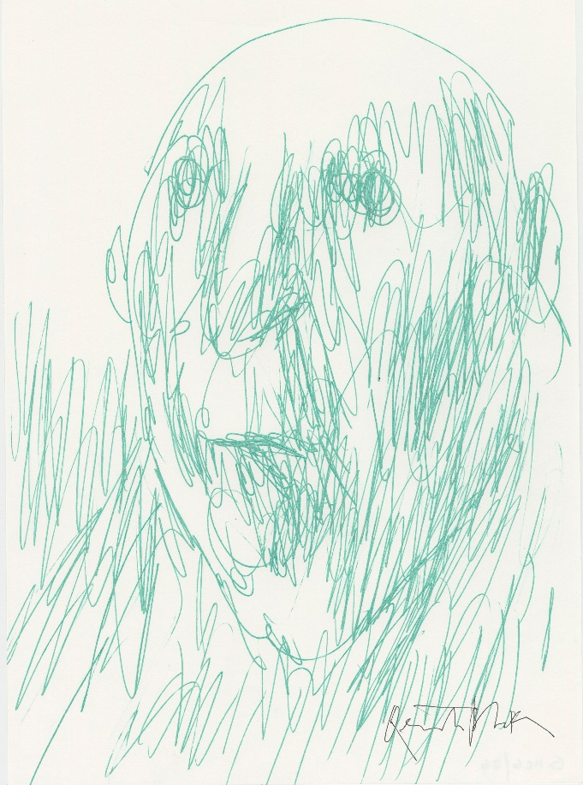
Quentin Blake – A Hundred Portraits
16 March – 8 September 2024
This spring, the legendary artist Sir Quentin Blake returns to Hastings Contemporary with an exhibition of one hundred unique imaginary portraits.
Every artwork will be for sale and has been philanthropically donated by Sir Quentin, with prices starting at a few hundred pounds. Sir Quentin is Hastings Contemporary’s Artist Patron, supporting the gallery in its charitable mission to bring world-class art to the town for the benefit and enjoyment of everyone.
Quentin says, ‘For 40 years, I had an ancient house in Hastings Old Town, with boats close by, and then one day they built an art gallery at the bottom of the street. I have spent a lot of time over the years creating commissioned work, and Hastings Contemporary has inspired in me a freedom to make work for myself. Next year the Quentin Blake Centre for Illustration will open in London, but Hastings will always be my spiritual home.’
The portraits on display will range from large works in watercolour pencil to postcard-sized pieces in biro.
Speaking about the creative process behind these works, Quentin says, ‘When I start to draw, I might have a sense of whether it will be a man or woman, young or old, but I discover the person while doing it… slowly I begin to meet the person and find out who they are.’
Liz Gilmore, Director of Hastings Contemporary says, “Whoever you are and however you do it, drawing can be transformative! These inspiring words stated by Quentin in our conversations about the making of this show capture the ethos and intentions of our gallery and the exhibition. Hastings and Rother is a place of astonishing creativity, we are inviting everyone to visit the gallery and make use of our Drawing Hub, a dedicated space for all ages and abilities to enjoy the power of drawing.’
‘At Hastings Contemporary we recognise the vital and transformative power of art to transcend boundaries and borders. We launch this show in tandem with the rollout of our local ticket discount to include Rother residents, as well as Hastings residents, so more people than ever can visit the gallery for half price.’
The exhibition marks the start of Hastings Contemporary’s spring season and opens on Saturday 16 March alongside an exhibition of work by leading Ethiopian artist, Elias Sime. Sir Quentin is also working on a written text which the gallery has commissioned to coincide with the exhibition.

NOTES FOR EDITORS
High resolution images for media use can be downloaded here
Sir Quentin Blake was born in 1932. He read English at Downing College, Cambridge; Education at the London Institute of Education and attended life classes at Chelsea School of Art. He taught illustration for over twenty years at the Royal College of Art. His first children’s book, A Drink of Water by John Yeoman, appeared in 1960, and since then he has worked on over 500, collaborating with many other writers including Russell Hoban, Michael Rosen, and Roald Dahl. He is also known for his own picture books such as Clown and Zagazoo, and his illustrations for the Folio Society for classics such as Don Quixote, Candide and The Golden Ass. In the past twenty years he has also worked on many projects for museums, hospitals, and other public spaces both in England and in France. In 1999 he was appointed first Children’s Laureate. He was knighted in 2013 for services to illustration, and he is also a Chevalier of the Légion d’Honneur. In 2022, he was appointed Companion of Honour in the Platinum Jubilee Honours List. He has written three books about his own work, Words and Pictures, Beyond the Page and Pens Ink and Places (published by Tate Publishing). He lives in London.

Hastings Contemporary brings world-class modern and contemporary art to a spectacular coastal setting. An ambitious programme of temporary exhibitions showcases work by internationally celebrated artists and emerging practitioners, often in Kunsthalle-style displays. Innovative programming, partnerships and collaborations support a commitment to outreach, learning and participation. The award-winning building is located on the town’s historic fishing beach among the net huts and working structures of the fishing fleet. Hastings Contemporary is a registered charity (charity number: 1150383).

For more information about Hastings Contemporary, visit www.hastingscontemporary.org / X @_art_on_sea / Facebook ‘hastingscontemporary’ / Instagram @_art_on_sea

FOR MORE INFORMATION, INTERVIEWS, AND IMAGES
Sophia McNab, sophia@hastingscontemporary.org, 01424 728377

