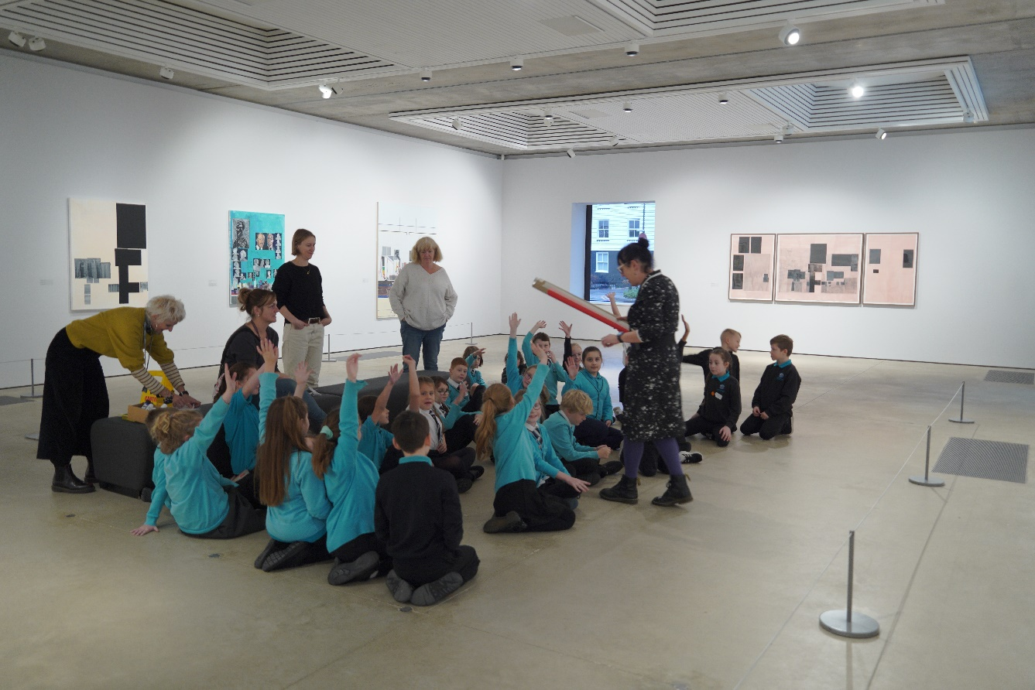
Pearls of the Sea: The Sea and Me
27 March 2024 - 2 June 2024

A vibrant exhibition showcasing the work of 400 local students opens at Hastings Contemporary this spring.
Pearls of the Sea: The Sea and Me is the culmination of a year-long collaboration between Hastings Contemporary and eight local schools, and will showcase and celebrate the students’ creations.
Pearls of the Sea is Hastings Contemporary’s flagship schools programme. Since its launch in 2015, the programme has given thousands of local students the opportunity to respond to modern and contemporary artworks, explore their creativity in the gallery’s learning studio, and get inspired by seeing their art displayed alongside internationally celebrated artists.
Throughout the academic year, students from eight Hastings and St Leonards schools have been working with local artists in a series of gallery visits, school visits and workshops. Teachers are provided with Career Personal Development sessions to enhance their arts delivery skills.
This year 400 students have created eight collaborative art pieces exploring their relationship with the local coastline and environmental issues. Works include cyanotype banners, mosaics, clay tablets, seaweed-dyed fabric, stick-and-ink illustrations, puppetry and two ambitious on-site installations.
Participating students and their families are given complimentary gallery entry to view and celebrate their work.
Helen Foster, Higher Level Teaching Assistant at Ore Village Primary Academy said ‘Our students love taking part in Pearls of the Sea. For many of them it’s their first visit to Hastings Contemporary, and for all of them it’s the first time their artwork has been displayed on the gallery walls. It’s a journey of discovery – a chance to feel welcome and comfortable at a gallery, to work with a local artist and get creative, and to try something new and boost their confidence. Our students don’t get many opportunities like this and it’s been a real highlight of the year.’
Leah Cross, Director of Programmes at Hastings Contemporary said ‘Pearls of the Sea is such a valuable part of our programme and a joy to deliver. We are so proud to showcase the outstanding creative talent of local Hastings schoolchildren.’
Louisa O'Shaughnessy, Learning Coordinator at Hastings Contemporary said ‘It’s an honour to work on this project and to meet so many enthusiastic and talented students and teachers. I hope all the participants are really proud of what they have achieved, and that the exhibition confounds expectations of children’s art.”
The exhibition is part of Hastings Contemporary’s spring season and will appear alongside an exhibition of work by Sir Quentin Blake and leading Ethiopian artist Elias Sime.
NOTES TO EDITORS
All media enquiries: Sophia McNab, sophia@hastingscontemporary.org
IMAGES CAN BE DOWNLOADED HERE
Pearls of the Sea Participating schools 2023-24:
Ark Blacklands Primary Academy, years 3 and 4, working with Olivia Abdallaoui
Ark Castledown Primary Academy, year 3, working with Hattie Collins
Baird Primary Academy, year 5, working with Toya Walker
Churchwood Primary Academy, years 4 and 5, working with Joseph Legg
Dudley Infant Academy, year 2, working with Dagmara Rudkin
Ore Village Primary Academy, year 4, working with Toya Walker
Saxon Mount School, year 9, working with Janey Moffat
Sacred Heart Catholic Primary School, year 1, working with Gilda Silva
HASTINGS CONTEMPORARY brings world-class modern and contemporary art to a spectacular coastal setting. The gallery welcomes everybody, and through our exhibitions and activities we aim to enrich lives by offering new experiences, supporting creativity and helping our town to thrive. We are proud of our innovative programming, partnerships and collaborations that support our commitment to outreach, learning and participation. Over the last 11 years we have established ourselves as a celebrated cultural hub for the South East. The award-winning building is located on the town’s historic fishing beach among the net huts and working structures of the fishing fleet.
Tickets can be booked in advance online. Hastings and Rother residents go half price for £5.50. Up to four under 18s go free with each adult ticket.
For more information about Hastings Contemporary, visit www.hastingscontemporary.org / X @_art_on_sea / Facebook ‘hastingscontemporary’ / Instagram @_art_on_sea

