Make a difference to the arts in Hastings – Join the Board of Hastings Contemporary
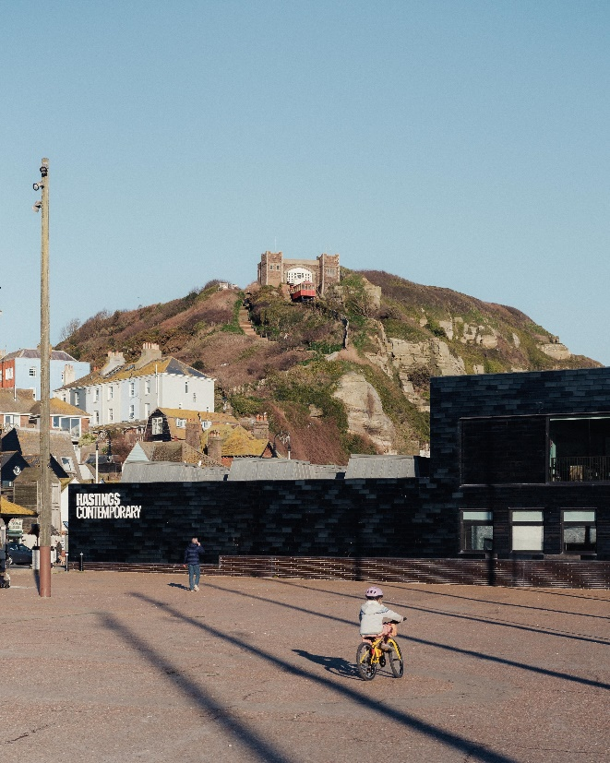
Our Board of Trustees is currently seeking a new Chair and new members
At Hastings Contemporary we bring world-class modern and contemporary art to a spectacular coastal setting. The gallery welcomes everybody, and through our exhibitions and activities we aim to enrich lives by offering new experiences, supporting creativity and helping our town to thrive.
We are proud of our innovative programming, partnerships and collaborations that support our commitment to outreach, learning and participation. Over the last 11 years we have established ourselves as a celebrated cultural hub for the South East.
We are situated right on the seafront, among Hastings’s famous net huts, overlooking the largest beach-launched fishing fleet in Europe. Designed by HAT Projects and originally created by the Jerwood Foundation, our building has won several architectural awards, including a RIBA National Award, a Civic Trust Award and a Sussex Heritage Trust Award. This is an exciting and challenging time to join Hastings Contemporary as we seek to build on the success of the last decade and ensure our beautiful gallery continues to thrive as a key part of the regional arts ecology.
As funding for the arts is squeezed across the UK, we are looking to build new income generation schemes and create even deeper engagements with the Hastings community. Our immediate income priorities for the coming year include engaging with the Government’s Levelling Up agenda and the funding available to communities such as Hastings to spread opportunity more equally and continuing our status as an Arts Council England National Portfolio Organisations.
In order to help us achieve these strategic priorities, we are seeking to develop and grow our Board of Trustees with a new Chair and board members across a range of skills and backgrounds from senior leadership across business and culture to community representation.
You can find out more about Hastings Contemporary and the Board at: www.hastingscontemporary.org and
www.hastingscontemporary.org/about-us/#board-of-trustees
Our Board of Trustees is currently seeking a new Chair and new members
We are looking to recruit a new Chair and two new trustees who will share our passion for the visual arts and belief in how galleries can change lives for the better. We are looking for people who represent the diverse perspectives and experiences of Hastings and Sussex life, and people with skills and experience to help us on our journey.
The Board has overall responsibility for the gallery and its activities and acts as its governing body. Members of the Board of Trustees are legally responsible for directing the affairs of the gallery, ensuring that it is solvent, well run, and delivering to its charitable objectives.
In addition to looking for a new Chair, we are especially keen to welcome new Board members from the following groups:
- Residents of Hastings and Rother with strong local knowledge of Hastings, Rother and its communities
- Younger people from Hastings and its surrounding areas - aged 18 to 35

For our Trustee roles, it is not essential to have been in a formal governance role before or to have a detailed knowledge of the visual arts.
Hastings Contemporary is a charity registered in England and Wales Charity no 1150383. Find out more about us at www.hastingscontemporary.org/

Terms of the appointment
Both the Chair and Trustee roles are unremunerated role, though reasonable expenses may be reimbursed. The Chair and Trustees are appointed on a four-year term. The maximum is two terms.
Board meetings are held at the gallery 4 times a year. Board papers and reports are circulated a week before the meeting. The overall time commitment for the Chair role is expected to be 2-3 days a month, with Trustees being expected to commit 1-2 days a month.
Desirable skills for Chair
- Excellent relationship-building and communication skills. Able to take on an ambassadorial role for Hastings Contemporary and to represent the gallery across a wide range of external stakeholders including funders, partners, and policymakers
- Capacity for strategic thinking for longer-term development of Hastings Contemporary
- Passion for the visual arts and the power of art to transform lives
- Sufficient time, energy, enthusiasm, drive, and determination
- Ability and contacts to support philanthropic and other forms of fundraising, especially trusts and foundations
- Experience of working at Board level, ideally with prior experience in a chairing capacity, whether in the commercial, public, or not-for profit sectors
- Strong understanding of governance and the role of a non-executive Chair, with a focus on leading and developing the Board
- Understanding of financial accounts and the financial drivers at play in arts organisations
Desirable skills for Trustees (applicants do not need to demonstrate all these skills – we are seeking to create a balance of these skills across the Board of Trustees.)
- Knowledge and understanding of the challenges and opportunities in Hastings and surrounding areas
- Sound independent judgement, and ability to be diplomatic and act as an ambassador for the charity
- Able to think creatively and work effectively as a member of a team and to take decision for the good of Hastings Contemporary
- Willingness to learn and passion for the work of Hastings Contemporary
- Entrepreneurial skills across business and culture, particularly individuals who could help us develop creative and innovative new earned income streams
- Experience of developing and delivery capital projects
- Experience of working in and with representative Hastings communities – for example, the local arts and creative community, local business community, voluntary sector, disadvantaged and deprived communities, ethnic minority communities
- Curatorial expertise and networks in the visual art world, in either commercial or not-for-profit sectors
Equal opportunities
Hastings Contemporary is committed to equality of opportunity in all its activities and employment practices. We actively encourage people from a variety of backgrounds with different experiences, skills, and stories to join us and influence and develop our working practice.
How to apply
To apply for either the Chair or Trustee role of Hastings Contemporary please submit both a short cover letter outlining why you would like the role and your relevant experience and your CV to Joni O’Sullivan (joni.osullivan@gmail.com) by 21 April 2024. Both the CV and Cover letter should be no more than one page each.
As an alternative to a cover letter and CV, candidates are welcome to submit a short (less than five minutes) phone/tablet film or audio recording outlining the above.
If you would value an informal conversation about being a Trustee at Hastings Contemporary, please contact Joni O’Sullivan (joni.osullivan@gmail.com)

