Hastings Contemporary announces major spring exhibition - Elias Sime: Eregata እርጋታ - from one of Ethiopia’s leading contemporary artists
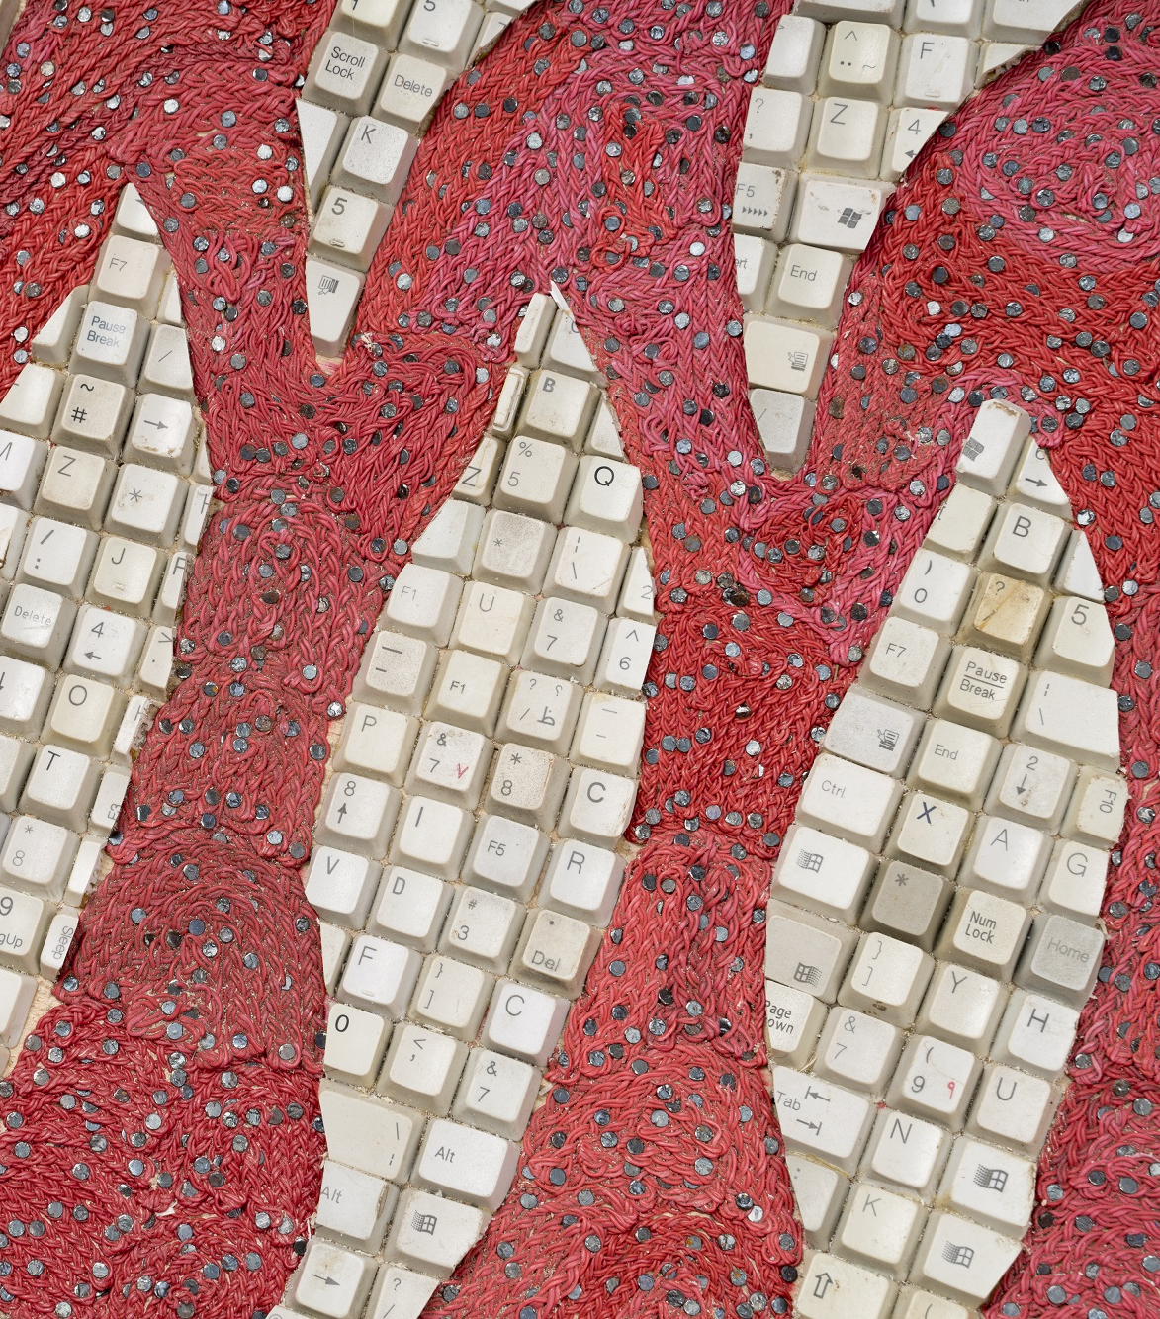
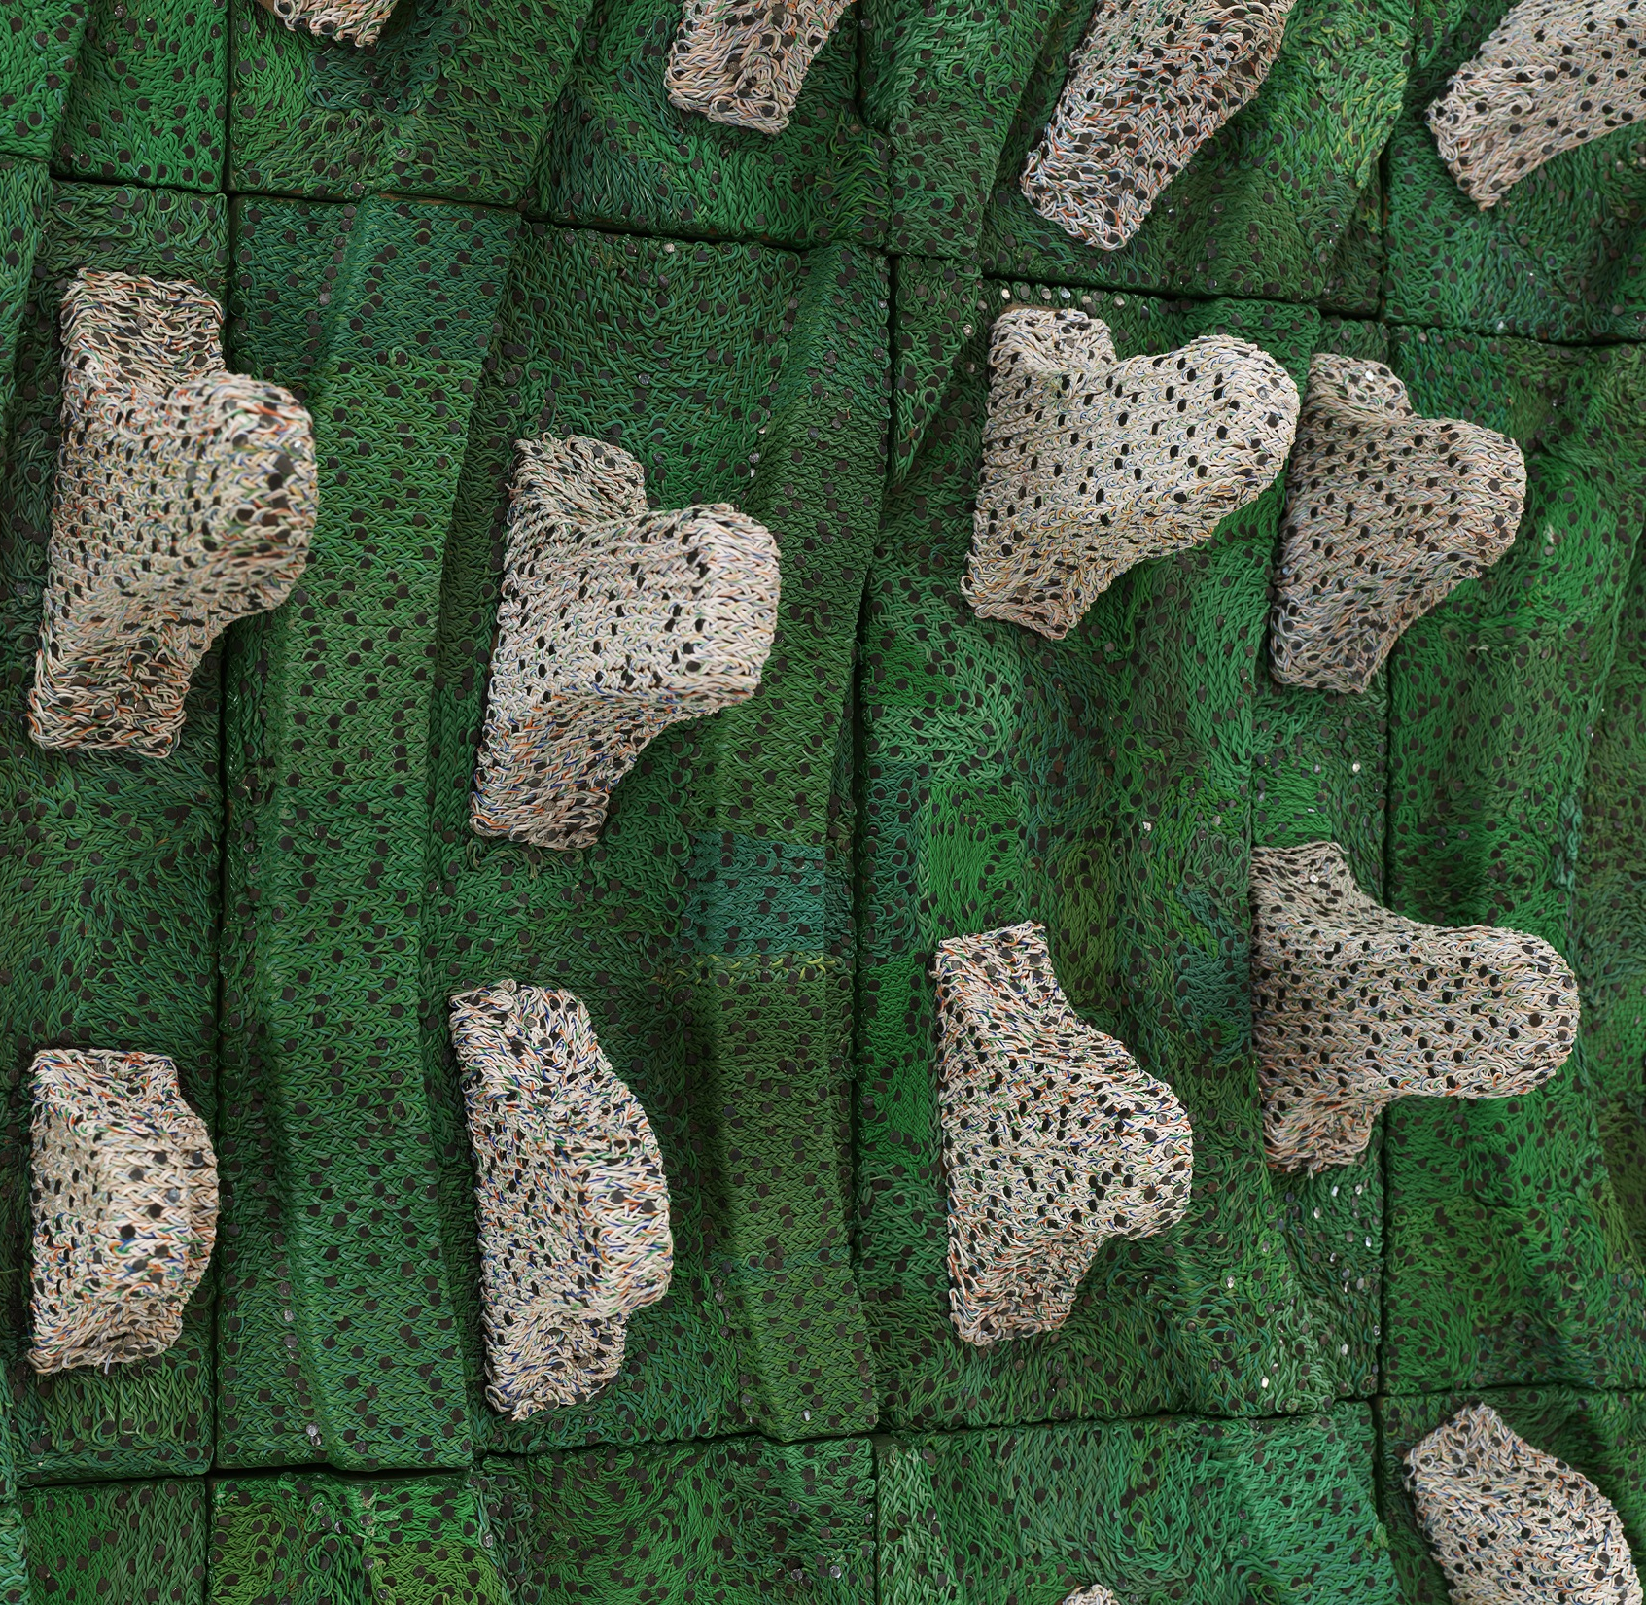
16 March – 8 September 2024
Hastings Contemporary, one of the UK’s leading contemporary galleries on England’s south coast, is delighted to announce that it will open this spring with a spectacular show from one of Ethiopia’s most exciting contemporary artists, Elias Sime.
Elias Sime: Eregata እርጋታ opens on Saturday 16 March and celebrates the work of this multi-disciplinary artist, who fuses extraordinary craftsmanship with a plethora of man-made objects.
Elias’s work has been lauded across the globe and will feature prominently at the 2024 Venice Biennale. His artistic approach is so relevant in today’s unstable world, encouraging us to re-examine our relationship with our environment.
Eregata እርጋታ will focus on the last decade of Elias’s career, with over 20 works on display, including complex and lyrical abstract topographies from his landmark series Tightrope (2009-present), and Bareness (2014), a large-scale ceramic installation consisting of 192 clay vessels.
Elias’s work is a record of the global exchange of commodities and how they are transformed from raw materials to machine, then into waste and finally their renaissance as art. The artist is revered for his progressive fusion of matter and artistic ideas, exploring global issues of sustainability, the resources we consume, and the impact of technology on today’s society.
The exhibition title Eregata እርጋታ is derived from Amharic, which the artist translates to the English word ‘serene’. Although one view of that word positively conveys a sense of stillness and calm, Elias describes ‘eregata’ as recognition that our minds are never truly still or calm: ‘we struggle to stop and sleep because our brains are constantly stimulated by technology - we are constantly moving faster not slower.’ Elias works against this fixation with technology, embracing a notion of slowness, ‘my art is slowing it down. The work forces me to slow down.’
Elias adopts a collaborative approach, working with a team of studio assistants to create his artwork; a process which is reflective of the reused and repurposed technological materials which have passed through numerous hands in their journey from raw material to waste.
Commenting on the exhibition, Elias Sime said: ‘Each material I collect has its own story, and has been touched by many hands. It has its own language. All the different stories related to the material move me, and I transform these intuitive reactions into my compositions.’
Liz Gilmore, Director of Hastings Contemporary said: ‘As part of Hastings Contemporary’s ongoing commitment to bringing world-class art to Hastings, we are thrilled to be launching our spring season by showcasing the work of Ethiopian artist, Elias Sime. Running concurrently with Sime’s exhibition in Venice, this ambitious exhibition offers fresh dialogue about globally important matters of environmental sustainability and the impacts of technology, made all the more poignant by the gallery’s unique position between land and sea.’
The exhibition marks the start of Hastings Contemporary’s spring season and will appear alongside an exhibition of work by Sir Quentin Blake. The gallery is also delighted to announce the extension of the half-price ticket offer to residents of Rother District Council in addition to Hastings District Council, with the aim of welcoming even more visitors to the gallery.
Elias Sime: Eregata እርጋታ originated at Arnolfini, Bristol UK, and is a collaboration with Hastings Contemporary and Kunstpalast Düsseldorf, Germany.
PRESS CONTACTS:
All Media Enquiries: A Star PR: Ian Roberts, ian.roberts@astarpr.com, / +44 (0) 7971191582 / www.astarpr.com
NOTES TO EDITORS:
Images:
Elias Sime, Veiled Whispers, 2021. Courtesy the artist and James Cohan Gallery. Photo Thomas Barratt.
Elias Sime, Tightrope Concave Triangle #2, 2020. Courtesy the Artist & GRIMM & James Cohan Gallery. Photo Jonathan de Waart.
HIGH RESOLUTION IMAGES FOR MEDIA USE CAN BE DOWNLOADED BY CLICKING ON THIS LINK
Elias Sime (b.1968 Addis Ababa, Ethiopia) deftly weaves, layers and assembles carefully selected everyday materials, transforming commonplace items into lyrical abstract compositions that suggest topography, figuration, and colour fields. He often creates intricate works from electronic components—including circuit boards, computer keys, and telecommunications wires. For Sime, the history of these materials hold meaning and their significance emerges after thorough consideration. They suggest the tenuousness of our interconnected world, alluding to the frictions between tradition and progress, human contact and social networks, nature and the man-made, and physical presence and the virtual.
Sime’s work achieves effects from dense narrative to austere modernist abstraction. He is as interested in a stripped motherboard from a mobile phone as he is an animal skull or worn-out button: the artist looks past the emotional weighting of new versus old, instead finding renewal everywhere, and taking greatest interest in the way that objects and ideas can connect in new ways.
Sime has a masterful handling of material, with fluency and pure formal instincts a hallmark of his practice. In the past decade he has sought to better understand the cultural and historic underpinnings of those instincts, traveling with the anthropologist Meskerem Assegued through rural villages in Ethiopia to research ancient rituals still in practice. Sime collects histories and vernacular techniques as much as objects.
As an extension of his art-making, Sime is involved in the exploration of vernacular architecture. Working with his longtime collaborator, Assegued, Sime co-founded, designed, and built the award-winning Zoma Museum in Addis Ababa, an environmentally conscious international art centre described by The New York Times in 2009 as “a voluptuous dream, a swirl of ancient technique and ecstatic imagination.” Zoma Museum celebrated its grand opening in its new location in March 2019, with expanded facilities that include a gallery space, library, children’s centre, edible garden, elementary school, art and vernacular school, amphitheater, cafe and museum shop.
Sime has exhibited extensively around the world. His work has been shown internationally at the 59th Venice Biennale which took place from April 23 to November 27, 2022; the Dak’Art Biennale of Contemporary African Art in Dakar, Senegal; the New Crowned Hope Festival in Vienna, Austria; and in the United States at the Metropolitan Museum of Art, New York; the Studio Museum in Harlem; and a survey exhibition that traveled from the Santa Monica Museum of Art, California, to the North Dakota Museum of Art. The Wellin Museum of Art at Hamilton College presented Elias Sime: Tightrope in the fall of 2019, marking the artist’s first major museum survey. Curated by Tracy L. Adler, the Wellin Museum’s Johnson-Pote Director, the exhibition highlights Sime’s work from the last decade, much of which comprises the series entitled Tightrope, alongside a selection of early works critical to the artist’s development. The exhibition traveled to the Akron Art Museum in Akron, Ohio, the Kemper Museum of Contemporary Art in Kansas City, Missouri, and the Royal Ontario Museum in Toronto, Canada in Spring 2021. Elias Sime: Tightrope is accompanied by the first monograph focusing on the work of Elias Sime, co-published by the Wellin Museum of Art and DelMonico Books • Prestel. Sime was also the subject of a solo exhibition entitled Currents 118: Elias Sime, on view at the Saint Louis Art Museum from July 2020 to January 2021. In 2019, Sime received an African Art Award from the Smithsonian National Museum of African Art and was shortlisted for the Hugo Boss Prize 2020.
HASTINGS CONTEMPORARY champions modern and contemporary art. An ambitious programme of temporary exhibitions showcases work by important Modern British artists, internationally celebrated artists and emerging practitioners, often in Kunsthalle-style displays throughout the building. The gallery has developed a reputation for its focus on painting. Innovative programming, partnerships and collaborations support a commitment to outreach, learning and participation. The award-winning building is located on the town’s historic fishing beach among the net huts and working structures of the fishing fleet.
Tickets can be booked in advance online, with proof of address required on arrival. Up to 4 children (under 18) go free of charge with each ticket.
For more information about Hastings Contemporary, visit www.hastingscontemporary.org / Twitter @_art_on_sea / Facebook ‘hastingscontemporary’ / Instagram @_art_on_sea

