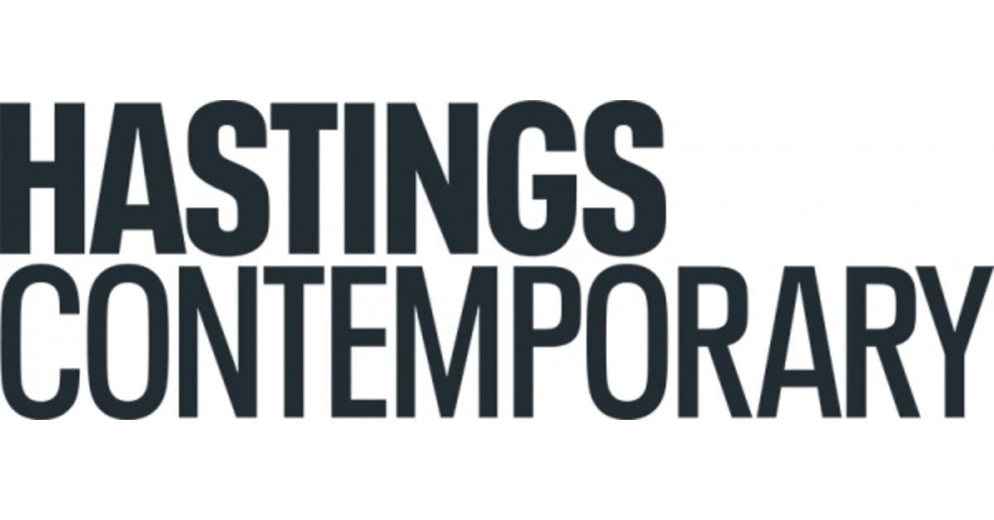

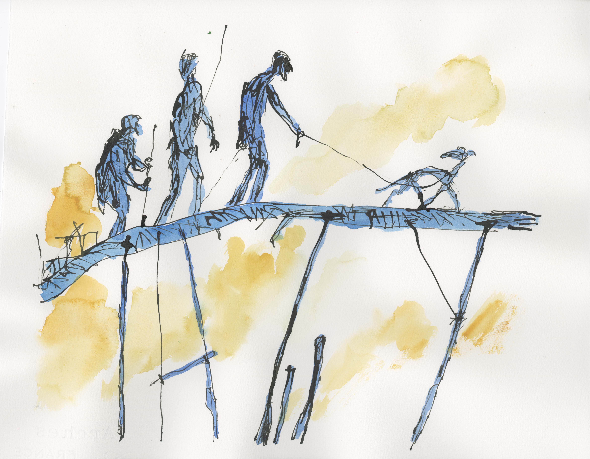

SIR QUENTIN BLAKE: INK
7 October - 12 November 2023
The irrepressible Sir Quentin Blake continues to be as creative and productive as ever. This autumn, the legendary artist is set to return to Hastings Contemporary with an exhibition of three new sets of pen drawings.
Sir Quentin says: “For 50 years of my professional life, I stood at the lightbox making drawings, many of them commissioned, with a scratchy pen and a bottle of black ink. More recently I have been exploring the artistic possibilities of a ballpoint pen. However, after 4000 imaginary portraits and many other drawings I thought it was time to go back to scratch.
There are three sets of new drawings here: High Places and Lofty Structures inhabited by bearded sages and vultures; VTT – les velos tout terrain – of my own inventing; and Imaginary Portraits. I would like to say they have been done “without making a single blot” – but that wouldn’t be true.”
Ink is the latest exhibition in a series of new works created by the East Sussex gallery’s Artist Patron, where previous shows, such as Feet in Water, Airborne and The Only Way to Travel have all been hugely popular. The new display has been created especially for Hastings Contemporary and will be on display at the Foreshore gallery.
For Sir Quentin, his ongoing relationship with Hastings Contemporary has opened up new possibilities, prompting him to explore new approaches and themes including migration and mental health, in the knowledge that the results will find themselves “sympathetically shown in this extraordinary gallery … they are truly pictures for Hastings Contemporary.”
In his typical, instantly recognisable and inimitable style, the 90 year old’s new pictures are full of movement, featuring phantasmagorical machines, characterful creatures and eccentric people. Recurrent themes of travel, the vitality of the human spirit, humour and a mischievious sense of the anarchic abound in these new drawings.
Liz Gilmore, Director of Hastings Contemporary explains the relationship between the gallery and the prolific artist, and also shares a little insight into the excitement around the new body of works.: “Our ongoing collaboration with Quentin continues to open up new creative possibilities, prompting him to explore new approaches and themes, such as migration and mental health. QB can do this in the knowledge that the results will find themselves sympathetically shown in our extraordinary building. Indeed, he said himself that the drawings he created for Ink are ‘truly pictures for Hastings Contemporary’. It is certain to be another lovely show, full of wonder and delight. ”
NOTES FOR EDITORS
HIGH RESOLUTION IMAGES FOR MEDIA USE CAN BE DOWNLOADED BY CLICKING ON THIS LINK
Image: High Places series. Photo courtesy of the artist.
Sir Quentin Blake was born in 1932. He read English at Downing College, Cambridge; Education at the London Institute of Education and attended life classes at Chelsea School of Art. He taught illustration for over twenty years at the Royal College of Art. His first illustrated book, A Drink of Water by John Yeoman appeared in 1960, and since then he has worked on over 300, collaborating, with many other writers including Russell Hoban, Michael Rosen, and Roald Dahl. He is also known for his own picture books such as Clown and Zagazoo, and his illustrations for the Folio Society to classics such as Don Quixote, Candide and The Golden Ass. In the past fifteen years he has also worked on many projects for museums, hospitals, and other public spaces but in England and in France. In 1999 he was appointed first Children’s Laureate. He was knighted in 2013 for services to illustration, and he is also a Chevalier of the Légion d’Honneur. He has written three books about his own work, Words and Pictures and Beyond the Page and Pens Ink and Places. He lives in London and Hastings.

Hastings Contemporary champions modern and contemporary art. An ambitious programme of temporary exhibitions showcases work by important Modern British artists, internationally celebrated artists and emerging practitioners, often in Kunsthalle-style displays throughout the building. The gallery has developed a reputation for its focus on painting. Innovative programming, partnerships and collaborations support a commitment to outreach, learning |and participation. The award-winning building is located on the town’s historic fishing beach among the net huts and working structures of the fishing fleet.

For more information about Hastings Contemporary, visit www.hastingscontemporary.org / Twitter @_art_on_sea / Facebook ‘hastingscontemporary’ / Instagram @_art_on_sea

FOR MORE INFORMATION, INTERVIEWS, AND IMAGES
Tracy Jones, Brera PR – tracy@brera-london.com / 01702 216658 / 07887 514984 / www.brera-london.com

