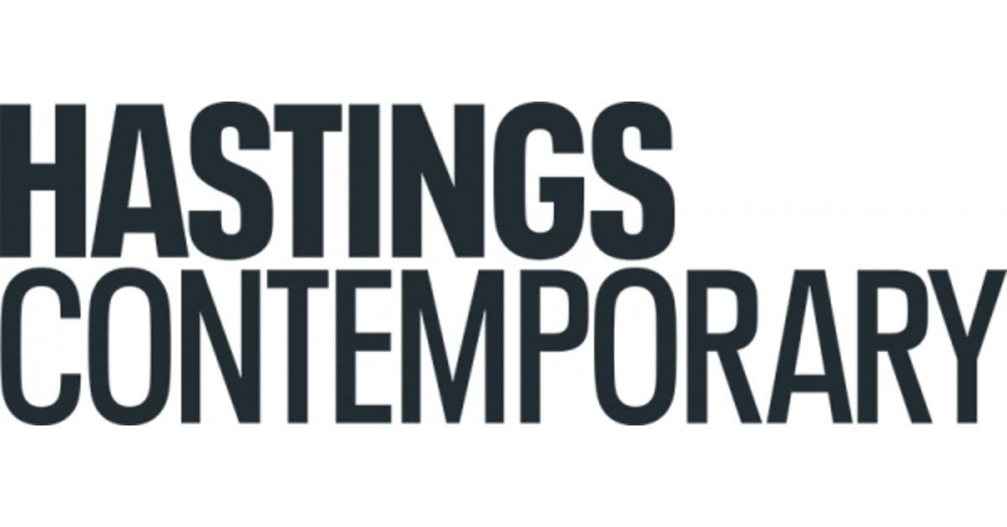

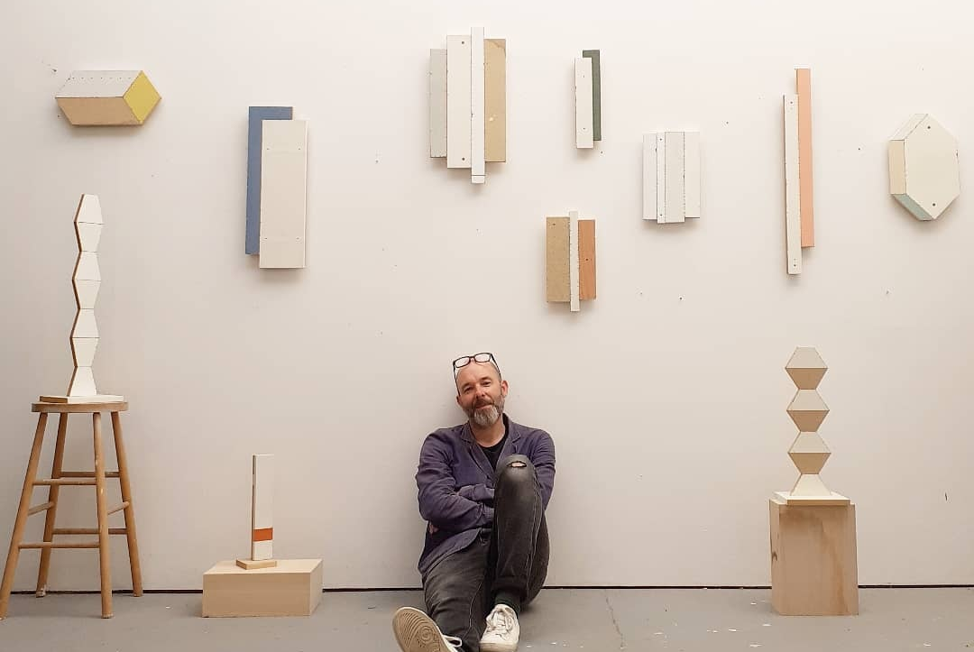

Roland Hicks: The Fourth Wall

7 October 2023 – 3 March 2024

Combining aspects of drawing, painting, still-life, geometric abstraction, collage and performance with sculpture, artist Roland Hicks will transform two galleries at Hastings Contemporary this autumn.

Working directly on sea-facing walls, Hicks will create the illusion of a flimsy patchwork of found materials, as if someone with rudimentary carpentry skills had hastily assembled a barrier out of whatever came to hand, inviting visitors to interpret the result as they see it themselves. Is it merely an act of folly? Perhaps an inadequate response to rising sea levels, or a paranoid reinforcement against supposed invaders? Some onlookers may see The Fourth Wall as a comment on the need for ‘make do and mend’ resourcefulness during the cost of living crisis, or a critique on consumerism and wastefulness.

Hicks will create The Fourth Wall in two phases, the first in Hastings Contemporary’s Gallery 7, with the second taking over an entire wall in Gallery 6. The preliminary stage begins by marking out a geometric design, then masking off and painting different shades and colours to suggest different doors, panels and other materials that could be used to fashion a maskeshift barrier. The process of adding details then continues until the illusion of a ramshackle assortment of found materials is complete.
“The Fourth Wall refers both to the literal description of the number of walls in each room, as well as the theatrical tradition of breaking the illusionary fourth wall between a stage and an audience. During the initial part of the show the public will still be able to see some of the creative processes involved taking place - at which point I will be both building and breaking the fourth wall simultaneously,” Hicks explains.
He adds: “All illusionistic art involves some kind of deception. These walls will effectively be built from misinformation and misdirection.”
His work often includes playful, art historical references and homages to influential artists and movements, normally 20th- century geometric abstraction. Here, visitors might detect a sense of Kurt Schwitters (1887-1948) and his Elterwater Merz Barn (1947-8) - which incorporated found items into a Cumbrian stone barn’s end wall and Robert Rauschenberg’s (1925-2008) Combines - which as their collective title suggests were a series of freestanding and wall-hung mixed-media pieces created between 1954 and 1964.
Hicks has also made three new totemic sculptural artworks which appear to be made out of discarded planks from the distinctive fishermen’s net stores on Hastings’ Stade, beside the gallery. About these, Hicks states: “I’d been struck by the black, light-absorbing surfaces of the huts, which reminded me of charcoal. This seemed appropriate for an exhibition that had its roots in a drawing prize.”
The Fourth Wall will certainly be ambiguous. Enigmatic even. As Hicks says: “I definitely prefer art that keeps asking interesting questions rather than trying to offer up easy answers or obvious explanations. Though, if I had to pin it down, I think I’d say that this show, like the rest of my work, probably all revolves around the slippery notion of ‘truthfulness’, both in art and life in general.”
Liz Gilmore, Director of Hastings Contemporary says: “Roland Hicks is the third winner of the brilliant initiative – the biennial Evelyn Williams Drawing Award. Hick’s creative invention stood out to the selection panel and we are now thrilled to be showcasing the works which have been developed as a consequence of this award. Hick’s distinctive and playful sculptural paintings will likely challenge and delight our visitors. We are thrilled that aspects of the work will be made by Hicks in situ.”

The Fourth Wall is the outcome of the £10,000 biennial Evelyn Williams Drawing Award made in association with the Trinity Buoy Wharf Drawing Prize 2021 exhibition. Roland Hicks was the recipient of the Evelyn Williams Drawing Award for his drawing Double Chip/Shuffle Zip in coloured pencil and acrylic gouache on paper cut out and his accompanying proposal to transform a gallery space at Hastings Contemporary. The Evelyn Williams Trust supports the biennial award, which is delivered in a collaboration between Drawing Projects UK, the Trinity Buoy Wharf Drawing Prize, and Hastings Contemporary.

NOTES FOR EDITORS

HIGH RESOLUTION IMAGES CAN BE DOWNLOADED BY CLICKING ON THIS LINK

Roland Hicks (b.1967) was born in Aldershot, Hants and studied at Winchester School of Art (1987-90), followed by the prestigious Slade School of Art (distinction) between 1994 and 1996. During a career spanning more than twenty years, his work has featured in numerous exhibitions in the UK, Denmark, Netherlands and Germany with his most recent solo show, Backstreet Geometry, in New York just last year (2022).

Exhibitions he has curated include The Tiresome Truth [also featuring Angela de la Cruz and Helene Appel] at ASC Gallery, London in 2019 and Humble As Hell [also featuring Susan Collis, Neil Gall, Nicky Hirst, Paul Housley, Duncan Macaskill, Stephen Palmer, Cathie Pilkington, Joel Tomlin and Richard Woods] at the Kurt Schwitters Merz Barn, Elterwater in 2017.

In 2021 he became only the third recipient (following Barbara Walker and Penny McCarthy) of the biennial Evelyn Williams Drawing Award, which was given during that year’s Trinity Buoy Wharf Drawing Prize exhibition. He has also twice been shortlisted for the Contemporary British Painting Prize in both 2018 and 2021, and is now a member of Contemporary British Painting artist group. He has also featured in The John Moores Painting Prize, The Creekside Open, Wells Art Contemporary, The Jerwood Drawing Prize, the Royal Academy Summer Exhibition and the NatWest Art Prize. He lives and works in London.

Hastings Contemporary champions modern and contemporary art. An ambitious programme of temporary exhibitions showcases work by important Modern British artists, internationally celebrated artists and emerging practitioners, often in Kunsthalle-style displays throughout the building. The gallery has developed a reputation for its focus on painting. Innovative programming, partnerships and collaborations support a commitment to outreach, learning and participation. The award-winning building is located on the town’s historic fishing beach among the net huts and working structures of the fishing fleet. For more information about Hastings Contemporary, visit www.hastingscontemporary.org / Twitter @_art_on_sea / Facebook ‘hastingscontemporary’ / Instagram @_art_on_sea

Evelyn Williams (1929-2012) was a figurative artist whose intense and quietly authoritative paintings, sculptures, reliefs and drawings were produced over a period of seven decades. In 1991, she and her husband created a modestly endowed trust dedicated to promoting the cause of drawing, particularly in art schools. Drawing was largely out of favour at the time and the seven substantial art school fellowships that were funded by the Evelyn Williams Trust over the following eight years did much to help re-appraise attitudes towards the practice. The Trust now has responsibility for the artist’s estate of extant works and her desired legacy of support to artists. (For the website see Evelyn Williams) To this end, the Trust collaborates with the Trinity Buoy Wharf Drawing Prize, Drawing Projects UK, and Hastings Contemporary to offer a biennial award of £10,000 to an artist selected from the Trinity Buoy Wharf Drawing Prize exhibitors, creating the opportunity for the awardee to make new work and show a resultant exhibition or equivalent presentation within the programme at Hastings Contemporary. 2023 Turner Prize nominee Artist, Barbara Walker MBE was the first recipient of the Evelyn Williams Drawing Award in 2017, with the solo exhibition Barbara Walker | Visual Artist | Vanishing Point being shown at Hastings Contemporary in 2018/19. Artist Penny McCarthy, the 2019 award winner, created the exhibition Cloud falls in Love with Mortal for its showing at Hastings Contemporary over autumn and winter 2022-23 which included a flim, Cloud falls in love with mortal : Penny McCarthy - YouTube. Fourth Wall is the exhibition created by Roland Hicks, the third recipient of the Evelyn Williams Drawing Award.
Drawing Projects UK was formed in 2009 by Professor Anita Taylor to deliver research initiatives in drawing, including the annual Jerwood (now Trinity Buoy Wharf) Drawing Prize exhibitions. In 2015, with curator Gary Sangster as co-director, Drawing Projects UK opened a Centre for Drawing and Contemporary Art in Trowbridge, the county town of Wiltshire. Situated in a landmark building, Drawing Projects UK houses a gallery, project space, studios and workspaces, meeting rooms and café; and aims to promote and develop public engagement in and through drawing in local, regional, national and international contexts by delivering on-site and off-site projects. A second centre for Drawing Projects UK is planned to open during 2024 at 1A West Bell Street in the centre of Dundee in Scotland.
The Trinity Buoy Wharf Drawing Prize annual exhibition project is led by its founding Director, Professor Anita Taylor, artist, founder of Drawing Projects UK, and Dean of Duncan of Jordanstone College of Art & Design at the University of Dundee. The Trinity Buoy Wharf Drawing Prize has been supported by the Trinity Buoy Wharf Trust since 2018, and is delivered in partnership with Trinity Buoy Wharf, University of Dundee, and Drawing Projects UK, and is project managed by Parker Harris. The Drawing Prize project was founded in 1994 as the Rexel Derwent Open Drawing Exhibition and known from 1996-2000 as the Cheltenham Open Drawing Exhibition. From 2001-17 it was known as Jerwood Drawing Prize and supported by Jerwood Charitable Foundation. Previous supporters have included Westland Nurseries, The Summerfield Charitable Trust, CHK Charities, and Rootstein Hopkins Foundation. The biennial Evelyn Williams Drawing Award is supported by the Evelyn Williams Trust and awarded to an artist included in Trinity Buoy Wharf Drawing Prize in partnership with Hastings Contemporary and Drawing Projects UK (2017, 2019, 2021, 2023). The Trinity Buoy Wharf Drawing Prize 2023 launches on 28 September 2023 at Trinity Buoy Wharf in London when the Awards with a total value of £27,000 will be announced, incuding the 2023 recipient of the Evelyn Williams Drawing Award.
FOR MORE INFORMATION, INTERVIEWS, AND IMAGES
Tracy Jones, Brera PR – tracy@brera-london.com / 01702 216658 / 07887 514984 / www.brera-london.com

