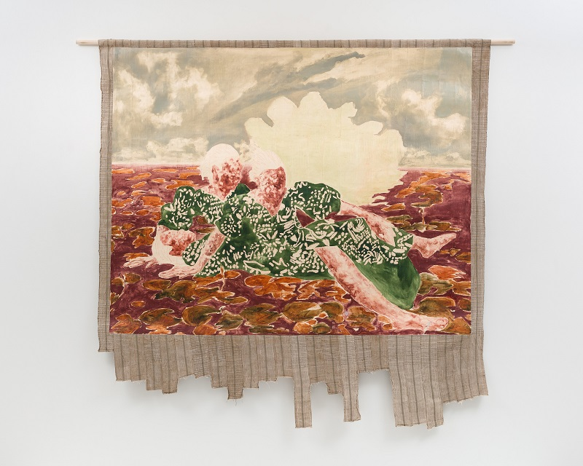

Nengi Omuku: The Dance of People and the Natural World
7 October 2023 - 3 March 2024
Hastings Contemporary is excited to announce the first major UK solo exhibition of new and recent works by Lagos-based artist Nengi Omuku, exploring her profound relationship with the natural world.
The Dance of People and the Natural World will not only introduce Omuku’s work to a wider UK audience, but also seeks to broaden the exposure and awareness of the vibrant contemporary Nigerian art scene.​
Displaying more than ten pieces​, the show spans five of Hastings Contemporary’s eight galleries, and includes works made between 2021 and 2023 that explore Omuku’s love of nature and the ways in which it provides her with a sense of safety and serenity. From 2021’s Lighthouse through to her latest, as yet to be titled work made this year (2023), the series focuses on a sense of re-immersion in nature. As Omuku explains: “This comes from both a personal place, telling my story as a gardener and florist, as well as what I feel is a collective leaning, and re-communion with nature today.”
Born in Warri, Nigeria, Omuku spent several years in London, studying at the Slade School of Fine Art. She has subsequently developed a distinctive style, which involves applying oil paint to gesso-prepared composite strips of the Nigerian fabric sanyan; a tightly-woven, hand-spun material that is an important aspect of Nigeria’s cultural history.
A further highlight of the exhibition at Hastings Contemporary will be the chance to see two new works (made this year), along with her largest piece to date, Eden (2022). The display of this monumental painting (measuring 224 x 520cms) includes stools, scatter cushions and pot plants, echoing Nengi’s own studio set-up in Lagos. The ensemble invites visitors to pause and relax, enjoying a moment of quiet reflection and respite. In Eden, Omuku invokes a sense of the biblical paradise and a longing for a pre-fall state of tranquillity, alongside a sense of the solace to be found in nature. Eden also acts as conduit between the other works on display by further expressing the artist’s theme of the rest and sanctuary afforded by the natural world. Eden represents an allegorical journey from darkness into light, as the eye moves from left to right across the canvas, following the passage of figures as they traverse a utopian landscape composed in a vivid, Fauvist palette of complimentary colours.
Welcome Home (2022) and Lighthouse (2021), both feature her signature spectral figures set in a dreamlike landscape. Still Life (2021) alludes to the time Omuku spent working as a florist and horticulturalist under her mother, while the foregrounds of Repose (2022) and Swing (2022) suggest the influence of Monet’s garden at Giverny on her work and the artist’s own research into Impressionism.
Looking ahead to the exhibition, her first major solo show in a UK public gallery, Nengi says: “It is a great privilege to have my first solo institutional exhibition at Hastings Contemporary, whose programme I have long admired for its far-reaching approach to painting. As a student at the Slade I dreamed of having a museum show in the UK, my home from home, and nowhere feels more fitting than Hastings Contemporary whose coastal location, for me, finds kinship with Lagos. The group of works presented focus on bringing love and light into the world, on concern for the environment and on sustainable practices to nurture and protect natural habitats.”
Liz Gilmore, Director of Hastings Contemporary shares Omuku’s sense of anticipation: “At Hastings Contemporary we strive to bring the very best contemporary art to the town. We are therefore thrilled to be hosting the inaugural public exhibition of work by Nengi Omuku. Our position between land and sea and natural heritage which flanks us – Europe’s largest and oldest beach-launched fishing fleet - has such resonance with the themes and concerns of Omuku’s practice, and provide a fitting backdrop to the beauty and tactility of her works.”

NOTES FOR EDITORS
HIGH RESOLUTION IMAGES FOR MEDIA USE CAN BE DOWNLOADED BY CLICKING ON THIS LINK
Nengi Omuku, Repose, oil on sanyan, 2022. Photo © the artist/Pippy Houldsworth Gallery.

Nengi Omuku - (b. 1987, Nigeria) lives and works in Lagos, Nigeria. She received her BA (2010) and MA (2012) from the Slade School of Fine Art, University College London. Omuku is the founder of The Art of Healing, an organisation that aims to transform inpatient mental health units in Lagos with contemporary art. She was artist-in-residence at Black Rock Senegal, as part of a programme founded by Kehinde Wiley in Dakar. She was included in the 2022-2023 Bangkok Art Biennale. Omuku’s solo exhibitions include those shown at Pippy Houldsworth Gallery, London (2022); Kristin Hjellegjerde Gallery, London and Berlin (2020, 2021); Stages of Collapse, September Gray, Atlanta (2017); and A State of Mind, Omenka Gallery, Lagos (2015). Omuku will be the sole contemporary artist included in the forthcoming Aso Oke: Prestige Cloth from Nigeria, an exhibition devoted to the history of Yoruba textiles, curated by Nichole Bridges at the Saint Louis Art Museum. Her past group exhibitions include What Lies Beneath: Women, Politics, Textiles, New Hall Art Collection, Murray Edwards College, University of Cambridge; Dissolving Realms, curated by Katy Hessel, Kasmin Gallery, New York; The Company She Keeps, Tiwani Contemporary, Lagos; Self-Addressed, curated by Kehinde Wiley at Jeffrey Deitch, Los Angeles (2021); The Invincible Hands, Yemisi Shyllon Museum of Art, Lagos, Nigeria (2021); Karim Kal and Nengi Omuku, La Galerie, Contemporary Art Center, Noisy-le-Sec (2021); and Dancing in Dark Times, Pippy Houldsworth Gallery, London (2021). Her works have been collected by public and private collections internationally, including Institute of Contemporary Art, Miami; Baltimore Museum of Art; Women's Art Collection, Murray Edwards College, Cambridge and The Whitworth, Manchester.
Hastings Contemporary champions modern and contemporary art. An ambitious programme of temporary exhibitions showcases work by important Modern British artists, internationally celebrated artists and emerging practitioners, often in Kunsthalle-style displays throughout the building. The gallery has developed a reputation for its focus on painting. Innovative programming, partnerships and collaborations support a commitment to outreach, learning and participation. The award-winning building is located on the town’s historic fishing beach among the net huts and working structures of the fishing fleet.

For more information about Hastings Contemporary, visit www.hastingscontemporary.org / Twitter @_art_on_sea / Facebook ‘hastingscontemporary’ / Instagram @_art_on_sea

FOR MORE INFORMATION, INTERVIEWS, AND IMAGES
Tracy Jones, Brera PR – tracy@brera-london.com / 01702 216658 / 07887 514984 / www.brera-london.com

