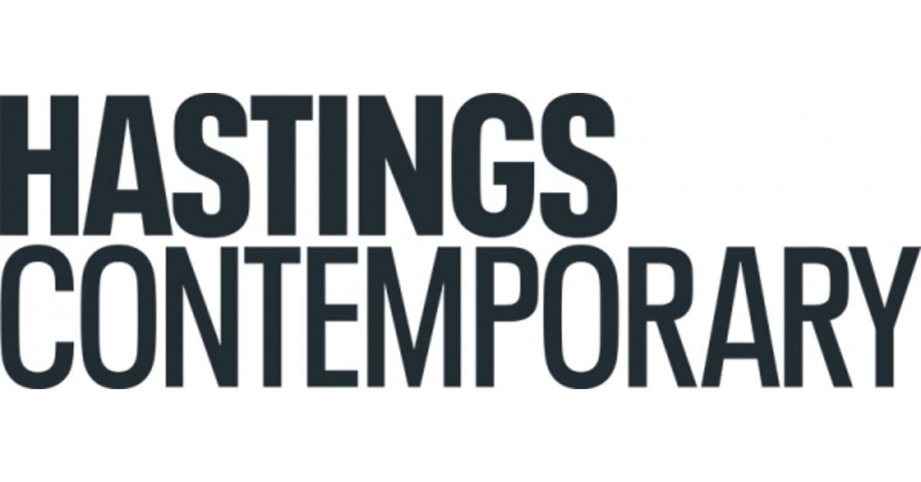

MAKING WAVES
8 October 2022 – 12 March 2023

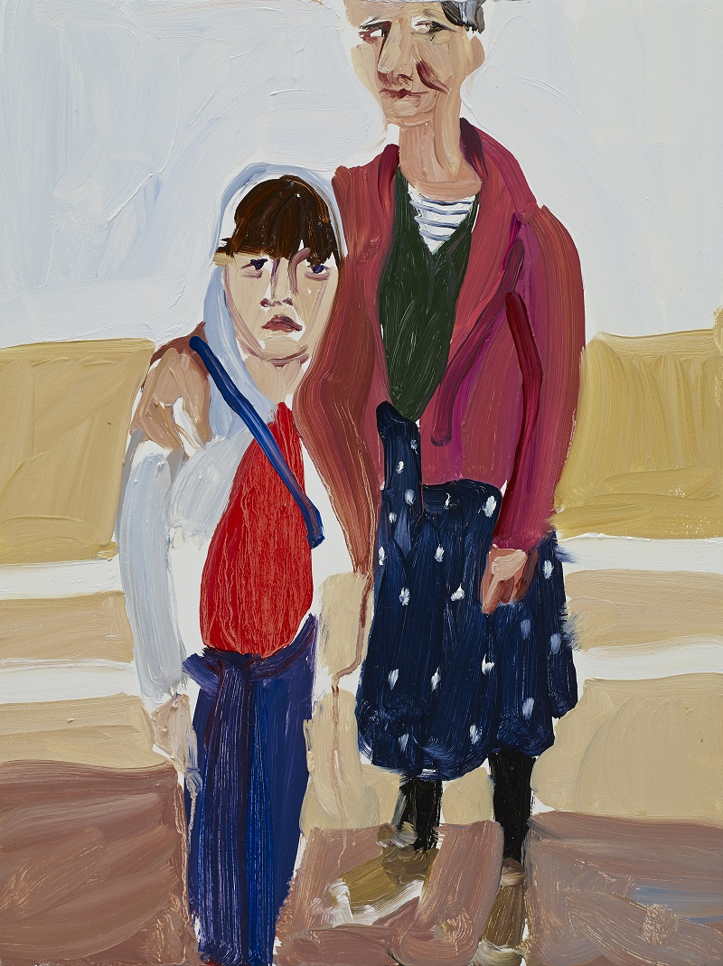
Ten incredible artworks are coming together to celebrate ten amazing years of contemporary and modern art in Hastings.
In 2012, nestled among the Old Town’s strange, black net shops and fronting a shingle beach, known since the Norman Conquest as The Stade, a striking new art gallery first opened its doors. What followed has been a decade of groundbreaking exhibitions, quality-packed retrospectives and important showcases for emerging and overlooked talent.
To celebrate its tenth anniversary, this autumn Hastings Contemporary will present Making Waves, a special alumni exhibition appropriately bringing ten artworks by ten of Britain’s most astonishingly talented artists, all of whom have exhibited in the gallery over this last decade, including Chantal Joffe, Rose Wylie, Maggi Hambling and Sir Quentin Blake. Other major artists set to feature in the exhibition are; Anselm Krut, Rachel Howard, Jeffrey Camp, Stephen Chambers, Anne Ryan and Gillian Ayres.
Announcing the show, Hastings Contemporary Director Liz Gilmore says: “Over the last ten years the response to the art we have shown has been phenomenal. We have been constantly punching well above our weight, with alumni artists to be proud of, all whilst receiving awards and positive reviews.”
In the post-pendemic era, Hastings Contemporary continues to build on its legacy of success, as Gilmore explains: “The volume of ever-increasing visitors coming from the local community and further afield demonstrate that Hastings has a vital role to play in artistic exchange. Since we first opened, as the Jerwood Gallery, over 400,000 people have visited our exhibitions, with many more engaging in our learning and participation programmes.
“Here is to more exhibitions to come, showcasing emerging and established artists and their work, making Hastings Contemporary a cultural hub of regional, national and international significance.”
More exciting announcements will follow in due course. In the interim, for more information about Hastings Contemporary, its current exhibitions, events and activities, visit www.hastingscontemporary.org / Twitter @_art_on_sea / Facebook ‘hastingscontemporary’ / Instagram @_art_on_sea

NOTES FOR EDITORS
HIGH RESOLUTION IMAGES CAN BE DOWNLOADED BY CLICKING ON THIS LINK

Self Portrait with Esme on the Promenade, 2014, Chantal Joffe. © Chantal Joffe. Courtesy the artist and Victoria Miro. Photo Stephen White
Hastings Contemporary champions modern and contemporary art. An ambitious programme of temporary exhibitions showcases work by important Modern British artists, internationally celebrated artists and emerging practitioners, often in Kunsthalle-style displays throughout the building. The gallery has developed a reputation for its focus on painting. Innovative programming, partnerships and collaborations support a commitment to outreach, learning and participation. The award-winning building is located on the town’s historic fishing beach among the net huts and working structures of the fishing fleet.

FOR MORE INFORMATION, INTERVIEWS, AND IMAGES
Tracy Jones, Brera PR – tracy@brera-london.com / 01702 216658 / 07887 514984 / www.brera-london.com

