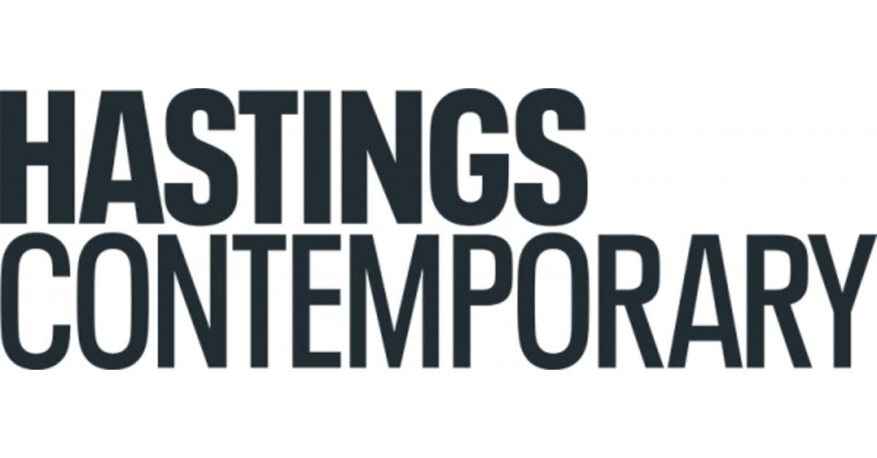
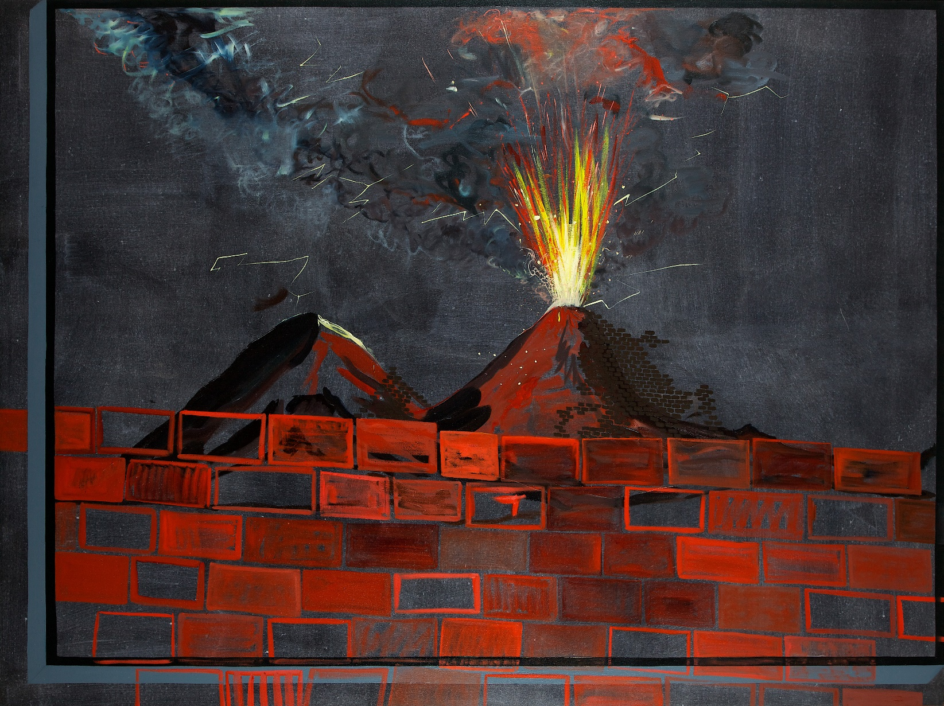
Caragh Thuring

8 October 2022 – 12 March 2023

In Autumn 2022, Hastings Contemporary will present a major survey show of the work of Caragh Thuring (b. Brussels, 1972) – her first UK exhibition in six years.
The show of more than 20 works will include paintings, drawings and monotypes created over the last 15 years. All works are on loan from the artist and public and private UK collections, in order to avoid the environmental impact of international shipping.
Thuring’s unique compositions oscillate between the humorous and the quotidian, juxtaposing signs and imagery from her recurring iconography of volcanoes, bricks, submarines, tartan, human silhouettes, and flora, and exploring where natural and manufactured worlds collide.
Thuring grew up in Scotland near to the Holy Loch, the site of the renowned Cold War US nuclear submarine base and also the construction site for the first concrete North Sea oil rigs. This clash of nature and industry has endured throughout her practice with looming submarine silhouettes, vast industrial structures and landscapes frequently appearing across different series. Similarly, Thuring incorporates a recurrent brick motif in her work, which for her perfectly represents the natural and the manufactured in a single object.
Thuring is curious about what lies out of sight. Volcanoes and submarines lurk beneath, intermittently breaking through to the surface. Brick walls obstruct our view and untreated or woven canvas draw our attention to the surface of the painting itself and what might lie beyond. What is not obscured is often fragmented, disrupting the viewer’s familiarity of what they are looking at.
For recent works, Thuring has commissioned bespoke cloth from silk weavers in Suffolk to use as her canvas. Digital renderings of previous paintings, photographs she has taken, or found images are woven on a loom, sewn together, and stretched before being painted onto. As she describes it: “I want to build the work into the surface, to continue the work I’ve already begun.”
Thuring’s fascination with boundary lines and liminal spaces is perfectly reflected in the gallery’s own position on the foreshore, surrounded by the town’s historic beach, net huts and working structures of the fishing fleet. Massacre of the Innocents (after Breughel), 2010, seems to echo the local towering architecture of the fishermen’s huts on Hastings beach, while the language of maritime and landscape permeate throughout the work.
Thuring says she is looking forward to the unprecedented experience of seeing her works created at different points through her career, together for the first time.
Hastings Contemporary Director Liz Gilmore says “Hastings Contemporary aims to champion the very best in contemporary art, particularly painting; so the work of the important mid-career artist Caragh Thuring is a perfect fit for our 10th anniversary year. Thuring’s work is fluid, intuitive, instinctual. The consistency of her output is extraordinary. Thuring has explored and returned to many motifs over the years, often in response to the geography/location and nature (including human nature). From volcanoes and their geological structures, nuclear submarines and landscapes, the clash of the natural and the manufactured… An exhibition of this nature, in our eco seafront gallery, consuming all our ground floor galleries will have dramatic impact yet also a strong resonance in Hastings and indeed nationally.”

NOTES FOR EDITORS

HIGH RESOLUTION IMAGES FOR MEDIA USE CAN BE DOWNLOADED HERE
- Caragh Thuring, August 1779, 2011. Oil and matting agent on dyed linen 182.9 x 243.8 cm. 72 1/8 x 96 in. © Caragh Thuring. Courtesy the artist and Thomas Dane Gallery. Photo: Richard Ivey

Caragh Thuring was born in Brussels in 1972 and has lived in the United Kingdom since 1973. Receiving a BA Hons in Fine Art from Nottingham Trent University in 1995, she moved to London the same year and currently divides her time between London and Argyll in Scotland.
Selected solo exhibitions include: Caragh Thuring, Luisa Strina Gallery, São Paulo, Brazil (2019); Builder, Corbett vs. Dempsey, Chicago IL (2019); Caragh Thuring, Thomas Dane Gallery, Naples, Italy (2019); Selected group exhibitions include: Mixing it Up; Painting Today, Hayward Gallery, London, England (2021); Masterpieces in Miniature: The 2021 Model Art Gallery, Pallant House Gallery, Chichester, England (2021); Vesuvio Quotidiano Vesuvio Universale, Museo di San Martino, Naples, Italy (2019). Slow Painting, England (2018/2019); Virginia Woolf, An exhibition inspired by her writings, Tate St Ives, Cornwall, England (2018).
Thuring’s works are in the collections of Tate, England; Arts Council Collection, England; Government Art Collection, England; and Alright-Knox Art Gallery, Buffalo, NY, USA as well as private UK and international collections.

Hastings Contemporary is a national beacon for modern and contemporary art in the Southeast of England. An ambitious programme of temporary exhibitions showcases work by important modern British artists, internationally celebrated artists, and emerging practitioners. The gallery has developed a reputation for its innovative programming, partnerships, and collaborations. The award-winning building is located on the town’s historic fishing beach among the net huts and working structures of the fishing fleet. For more information about Hastings Contemporary, visit www.hastingscontemporary.org / Twitter @_art_on_sea / Facebook ‘hastingscontemporary’ / Instagram @_art_on_sea

FOR MORE INFORMATION, INTERVIEWS, AND IMAGES
Tracy Jones, Brera PR – tracy@brera-london.com / 01702 216658 / 07887 514984 / www.brera-london.com

