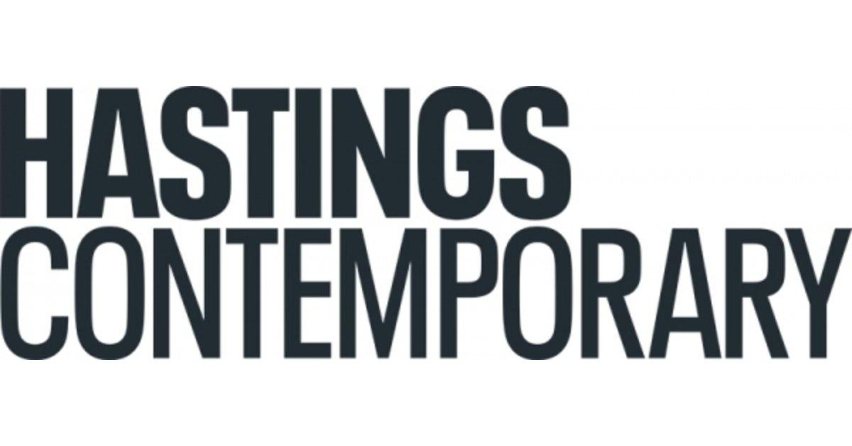
WE OUT HERE

1 April – 4 June 2023

We Out Here (WOH) is a ground-breaking exhibition showcasing the work of six Black artists of Caribbean heritage based in Hastings.

WOH artists will be creating new culturally specific artworks and collaborating to produce a distinctive, large-scale, multi-media show. Working in different mediums, the themes they will explore include migration, Black lives in coastal towns, relationships with the sea, climate justice and racial injustice, fast fashion and the Black presence in crafts.

WOH speaks to and engages with the Black and wider communities in Hastings. Complementing the show in the Foreshore Gallery will be a range of creative activities, events and discussions. We Out Here will also be complemented offsite with a series of community-based activities and workshops which aim to encourage art engagement.

The project is led by local artist Lorna Hamilton-Brown RCA MBE, known as the ‘Banksy’ of the knitting world for her use of the medium for social commentary. For WOH, Lorna will be creating a new ‘WE MEK’ knitted magazine cover – The Windrush 75 Issue. It will feature the celebrated author of Small Island, the late Andrea Levy and commemorate the 75th anniversary of the arrival of the Empire Windrush carrying passengers from the Caribbean to the UK.

Lorna says “We Out Here has given me the chance to bring together Hastings-based Black artists who I admire, from a range of disciplines to create a historic exhibition. We have been hidden in plain sight for too long, but WE OUT HERE!”

Liz Gilmore, Director of Hastings Contemporary says “Hastings Contemporary always strives to show the very best art, where possible showcasing new or overlooked talent. This exhibition realises these ambitions, celebrating the incredible creative talents of six artists living and working in Hastings.”

The artists also taking part in the exhibition are Paul Hope, Elaine Mullings, Eugene Palmer, Richard M Rawlins and Maggie Scott.

Hope will be referencing historic displacement through the Transatlantic Slave Trade, using embossed slave token images appropriated from the 1789 broadside ‘Description of a Slave Ship’. He will also be creating work exploring migration, arrival and assimilation, using traditional leatherwork techniques.

Creating two new, large-scale sculptures for the exhibition, Mullings will be using materials that highlight global exploitation in continental Africa in general and in particular, the Democratic Republic of the Congo.

Palmer will create two large paintings, as an invitation to the viewer to reflect on their relationship with the sea. The works will present the image of the Black subject juxtaposed with the image of the sea, and familiar visual elements we associate with British seaside culture.

Rawlins will exhibit his work, Conversation Over Tea and reimagine it with live performances. His work will also explore the Windrush Migration through his painting and a large graphite drawing that explores identity.

Scott’s focus on fast fashion and climate justice spotlights the consequences for the Global South of the Global North’s addiction to cheap clothing.

On 15 April at 2pm there will be a live WOH artists’ panel discussion hosted by writer Sarah Gwonyoma, exploring themes raised within the exhibition.

Artwork created by the pupils from eight local schools will also be on display in the gallery during WOH. They will be responding to ‘Making your Mark’, a brief created by Lorna for Hastings Contemporary’s Pearls of the Sea school’s project.

A full-colour publication featuring the artists and their work will accompany the exhibition.

Community partners include Afri-Co-Lab, Home Live Art, Black Butterfly, Electric Palace Cinema, Hastings Borough Council and Hastings Museum and Art Gallery.

ARTIST QUOTES

Paul Hope – “We Out Here has allowed me to think about leathercraft outside of the more utilitarian confines of domestic small leather goods, clothing and fashion. It has provided a creative forum to explore themes of local culture, migration, movement and resettlement. Through placing artworks together in the gallery space, alongside the work of fellow black artists, a stronger creative narrative can be created.”

Eugene Palmer – “Hastings is a great place to live and work; its outlook is very much towards the future. Participating in the WOH exhibition gives me a unique opportunity to share my art-practice with an exciting group of artists, and with the diverse audience(s) of the local community.”

Maggie Scott – “It’s been exciting to work with such an experienced and diverse group of black artists; meeting regularly to talk about our work and share our thinking has been truly inspiring. In spite of many years of producing and exhibiting work in the USA, Canada, Belgium as well as many cities in the UK, the most challenging, interesting and supportive environment has come from the small coastal town of Hastings!”

Richard Mark Rawlins – “For me, being involved in WOH is more than just representation and more about the opportunity to share with the wider community some of what I have been making in this place, Hastings, that I have begun to make a home. My works are multi themed and in WOH I find my work in communion with 5 other artists who touch on similar themes, and I find that interesting.”

Elaine Mullings – “I am delighted to exhibit work in We Out Here at Hastings Contemporary and showcase new work expressing my on-going interest in form and materiality. As Black artists we have much to say about living in this coastal town. The exhibition also offers the community a chance to celebrate the creative contributions made by people of African Caribbean heritage and to remind us that Black lives do matter.”

NOTES FOR EDITORS

HIGH RESOLUTION IMAGES CAN BE DOWNLOADED BY CLICKING ON THIS LINK

WOH Full Programme Details
WE OUT HERE Exhibition :1 April to 4 June 2023
Opening times: Wednesday to Sunday, 11am – 5pm
Location: Hastings Contemporary, Rock-a-Nore Road, Hastings TN34 3DW

In conversation with WOH artist Paul Hope and African Art collector, Robert Mucci (Robert’s Rummage)
Sunday 2 April 2-4pm
Location: Hastings Contemporary (HC)

Family Day: Make a Fingie – Finger knitting workshop led by WOH Artist Lorna Hamilton-Brown
Thursday 6 April 11am-5pm
Location: HC

Conversations Over Tea – Performance #1, with WOH Artist Richard Rawlins and guest
Saturday 8 April, 3-4 pm
Location: HC

Exhibition Tour with WOH Project Lead, Lorna Hamilton-Brown
Wednesday 12 April, 7-8 pm
Location: HC

Racial Injustice workshop led by WOH Artist, Elaine Mullings
Thursday 13 April, 7-9 pm
Location: Afri-Co-Lab, 3 Marine Court, St Leonards On Sea

WOH Artists’ Panel Discussion hosted by writer, Sarah Gwonyoma
Saturday 15 April, 2-4pm
Location: HC

Leatherwork Hand Stitching Workshop led by WOH Artist Paul Hope
Friday 21 April, 12-3pm
Location: HC

Mary Lewis of Heritage Crafts Association hosts a virtual panel discussion with WOH Artists
Lorna Hamilton-Brown, Maggie Scott, Paul Hope and Elaine Mullings.
Wednesday 26 April, 6pm
Location: Online

‘Unfinished Sentences’ by Mariel Brown - Cinema Screening and Q&A
Thursday 4 May, 11am
Location: Electric Palace Cinema, 39a High Street, Hastings TN34 3ER

Exhibition Tour with W OH Artist Elaine Mullings
Wednesday 10 May, 7-8pm
Location: HC

Out of the Ordinary: Spectacle and the Everyday - Workshop led by WOH Artist Elaine Mullings
Friday 12 May, 12-2pm
Location: HC

Cross Stitch Workshop with Yemii Haastrup of Stitch TLC
Thursday 18 May, 2-4pm
Location: HC

Subversive Catwalk: Women, Fast Fashion and Climate Crisis led by WOH Artist Maggie Scott and a:dress.fashion
Sunday 21 May, 2-5pm
Location: HC

African Caribbean Seaside Memories Workshop + Hastings Museum and Gallery
Wednesday 24 May
Location: Hastings Museum and Art Gallery

‘The Black Presence in Craft’ Online Panel Discussion hosted by Rose Sinclair, Chair of the Crafts Council’s Equity Advisory Council, with WOH Artists Lorna Hamilton-Brown, Maggie Scott, Paul Hope and Elaine Mullings.
Tuesday 30 May 7- 8.30pm
Location: Online

Family Day: WOH Storytelling and activity workshop
Thursday 1 June, 11am-5pm
Location: HC

‘Queer Out Here’ Workshop led by WOH Artist, Elaine Mullings
Friday 2 June
Location: Home Live Art TBC

Conversations Over Tea – Performance #2 with WOH Artist, Richard Rawlins and guest
Saturday 3 June, 3-4pm
Location: HC

_______

Hastings Contemporary champions modern and contemporary art. An ambitious programme of temporary exhibitions showcases work by important Modern British artists, internationally celebrated artists and emerging practitioners, often in Kunsthalle-style displays throughout the building. The gallery has developed a reputation for its focus on painting. Innovative programming, partnerships and collaborations support a commitment to outreach, learning |and participation. The award-winning building is located on the town’s historic fishing beach among the net huts and working structures of the fishing fleet.

For more information about Hastings Contemporary, visit www.hastingscontemporary.org / Twitter @_art_on_sea / Facebook ‘hastingscontemporary’ / Instagram @_art_on_sea

FOR MORE INFORMATION, INTERVIEWS, AND IMAGES
Tracy Jones, Brera PR – tracy@brera-london.com / 01702 216658 / 07887 514984 / www.brera-london.com

