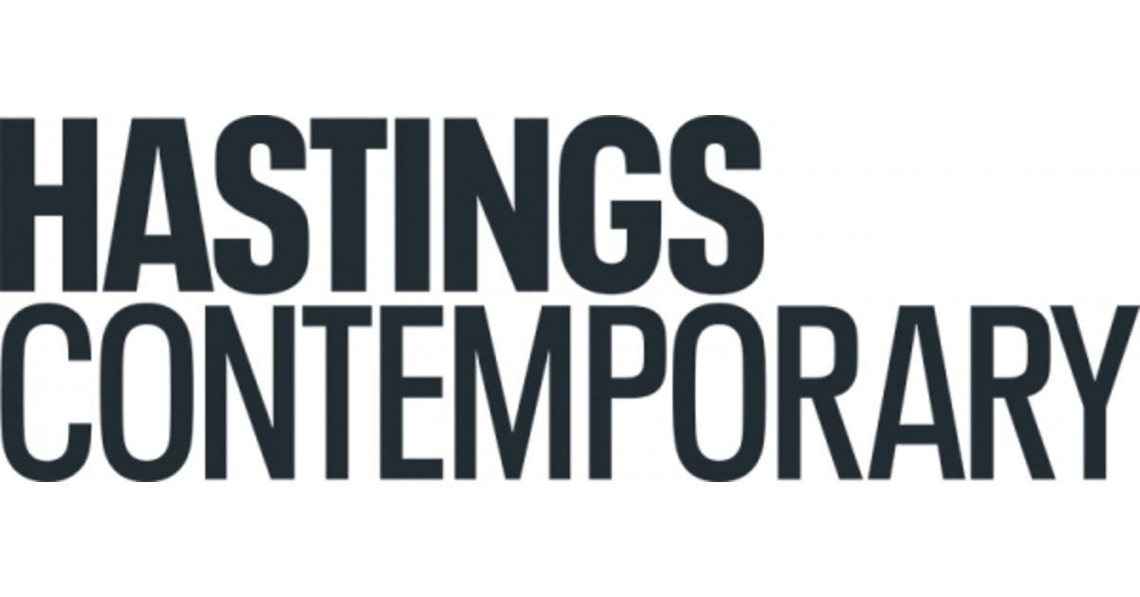

sOUTINE|kOSSOFF

1 April – 24 September 2023

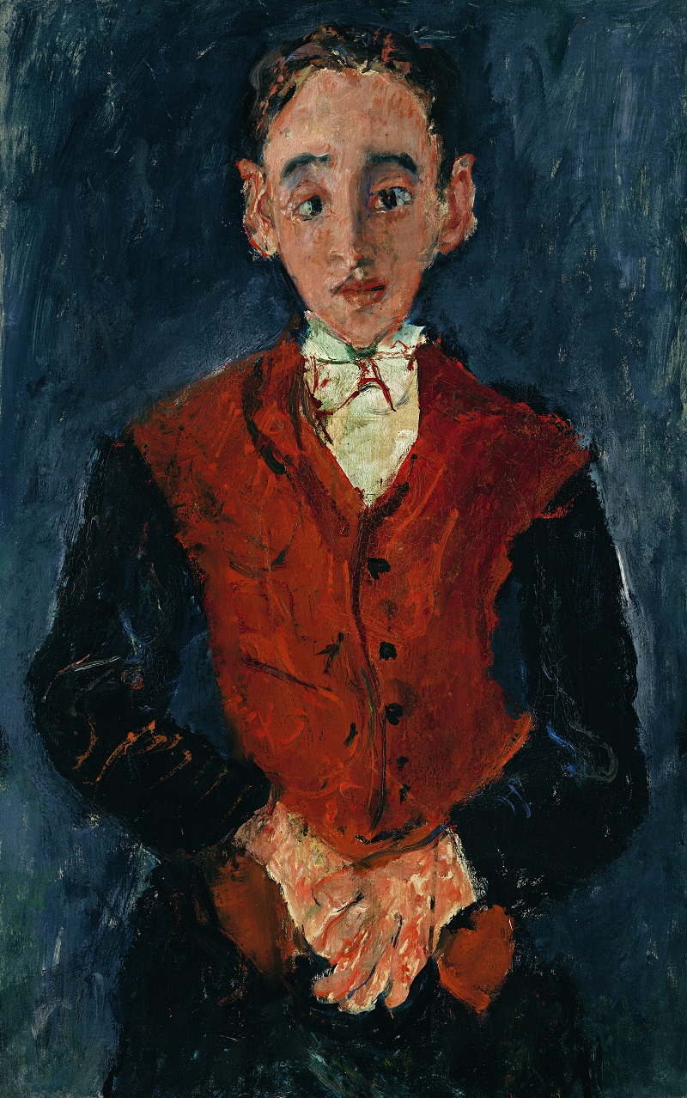
Opening at Hastings Contemporary in April 2023, Soutine Kossoff pairs two major figures of 20th-century painting: one a master of the School of Paris, the other a master of the School of London.
Soutine |Kossoff is the first ever museum exhibition to explore the artistic relationship between British artist Leon Kossoff (1926-2019) and Belarus-born painter Chaim Soutine (1893-1943).
Undertaken with the full support of the Kossoff estate, it brings together around 40 important loans from public and private collections in the UK, USA and beyond. Aside from Soutine Portraits (Courtauld, 2017) at around 20 works, this is the largest group of Soutines shown together in UK since 1982, and the first since then to show both portraits and landscapes, providing a fascinating follow-up to The Barnes Foundation’s 2021 show Soutine / De Kooning.
The discovery of Soutine’s paintings in the early 1950’s was a significant moment for Kossoff, who was already finding his way towards the kind of direct and expressive use of paint he saw in his predecessor’s work.
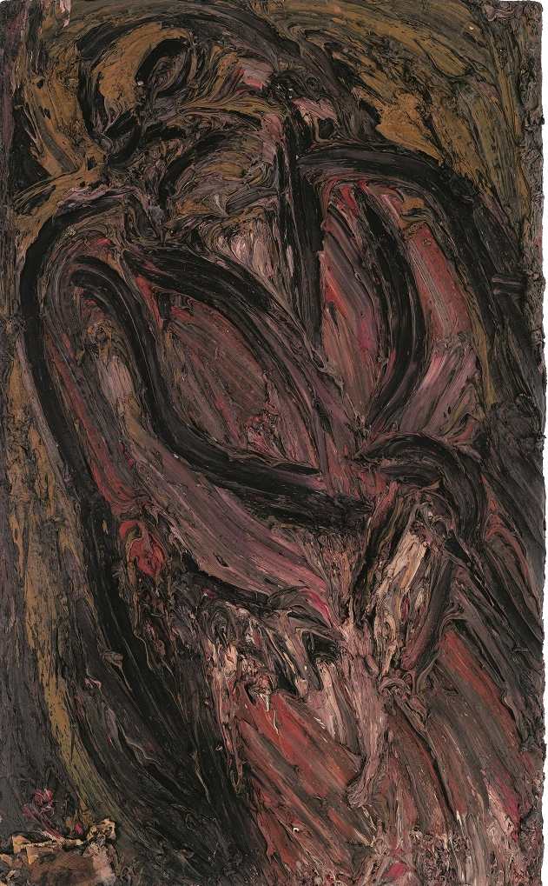
Soutine grew up in Belarus before migrating to Paris as a young man, while Kossoff was born and raised in London, his parents having arrived there from Ukraine as children. Although their life experiences were very different, the two artists shared an Eastern European Jewish heritage which perhaps brought a particular cultural sensibility to their work. To create transcendent works from the stuff of everyday life became Kossoff’s mission, as it had been Soutine’s.
The main focus of Soutine | Kossoff is on the areas of interest shared by both artists: landscape and portraiture. The exhibition features seminal landscapes painted by Soutine in southern France in the early 1920s, with highlights including Paysage aux cyprès (c.1922), and Cagnes Landscape with Tree, (c.1925-26, Tate). From Kossoff come major paintings of railway junctions, building sites and other scenes of unexpected beauty found in north and north-west London, among them Willesden Junction, Summer, No.2, (1966, Alfred East Art Gallery) and Demolition of the Old House, Dalston Junction, Summer (1974, Tate).
Visitors will have a rare opportunity to view Kossoff’s stunning Nude on a Red Bed, November – December 1972 alongside works such as his powerful Seated Woman (1957) and the striking Double Self-Portrait (1969, Louisiana Museum of Modern Art). A major group of Soutine portraits includes Le Petit Pâtissier (c.1927), Young Woman in a White Blouse (c.1923, Courtauld Institute) and Le Valet de Chambre (c.1927).
A publication will accompany the exhibition.
Soutine | Kossoff is curated by Hasting Contemporary’s guest curator James Russell, whose recent show Seafaring opened to a 4-star review from The Daily Telegraph. James’s previous exhibitions have enjoyed critical and commercial success. They include Seaside Modern (Hastings Contemporary, 2021), Reflection: British Art in an Age of Change (Ferens Art Gallery, 2019) and Ravilious (Dulwich Picture Gallery, 2015).

NOTES FOR EDITORS
HIGH RESOLUTION IMAGES CAN BE DOWNLOADED BY CLICKING ON THIS LINK
Le valet de chambre, Chaim Soutine, c. 1927. © The Lewis Collection
Seated Woman Leon Kossof, 1957 © Leon Kossoff Estate

Hastings Contemporary champions modern and contemporary art. An ambitious programme of temporary exhibitions showcases work by important Modern British artists, internationally celebrated artists and emerging practitioners, often in Kunsthalle-style displays throughout the building. The gallery has developed a reputation for its focus on painting. Innovative programming, partnerships and collaborations support a commitment to outreach, learning |and participation. The award-winning building is located on the town’s historic fishing beach among the net huts and working structures of the fishing fleet.

For more information about Hastings Contemporary, visit www.hastingscontemporary.org / Twitter @_art_on_sea / Facebook ‘hastingscontemporary’ / Instagram @_art_on_sea

FOR MORE INFORMATION, INTERVIEWS, AND IMAGES
Tracy Jones, Brera PR – tracy@brera-london.com / 01702 216658 / 07887 514984 / www.brera-london.com

