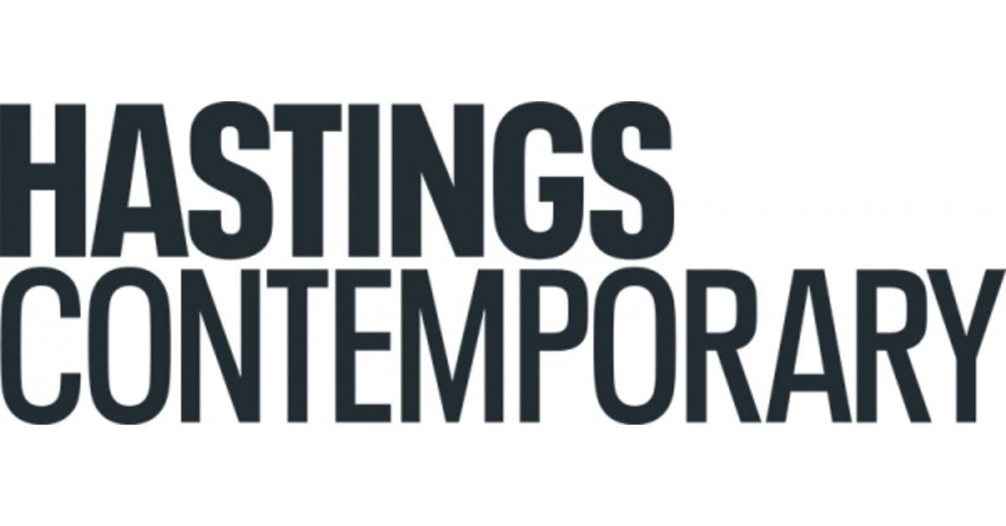

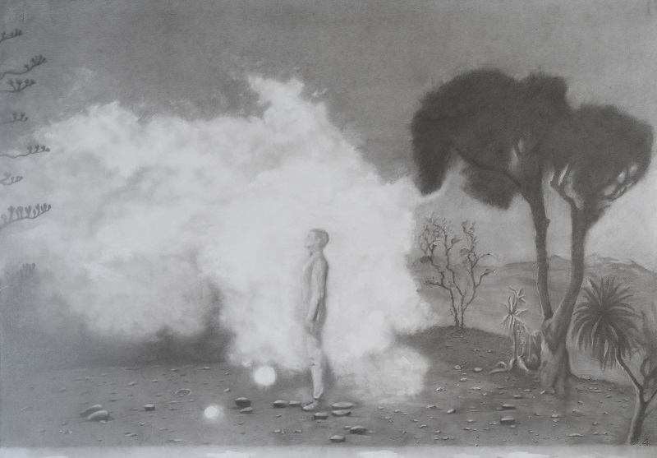

Penny McCarthy
Cloud falls in love with mortal
Solo exhibition by the 2019 Evelyn Williams Drawing Award Winner
8 October 2022 - 12 March 2023
Cloud falls in love with mortal is a solo exhibition by American artist Penny McCarthy (born 1960) and consists of an extensive series of graphite drawings made between 2019 and 2022. Penny received the biennial Evelyn Williams Drawing Award in 2019.
The catalyst for these drawings was a newspaper image from 2016, that looked like a portal to another world had opened in the sky above Hastings. This was a Fata Morgana – a type of mirage that significantly distorts the object on which it is based, so that the object is completely unrecognisable.
Each drawing in the series is linked to the enigmatic Fata Morgana mirage, in which the sea appears in the sky and the world is turned upside down, somehow coalescing the everyday and the sublime.
Penny McCarthy uses pencil drawing with an exacting slowness that is a kind of reverie or extended contemplation. Prevented by the pandemic from making her planned visits to Hastings, the artist instead made a speculative and metaphorical exploration of myths and narratives associated with the sea and sky. The suite of drawings is very much a reflection of an interior world conjured out of paper - clouds, water, dust, and light – all represented with a frugality that comes, at least in part, from being made during the turbulent time of the global pandemic.
Works explore the interplay between life and an art project: a drawing of a cat in the studio, a re-working of a rough sketch of a statue seen in Rome years ago that tells of a Greek myth, a drawing of the sea from memory, a re-imagined episode from Star Trek about a shape-shifting cloud. Each work attempts to make the familiar unfamiliar to register their strange particularity.

The exhibition also includes a series of postcards, and a short film made in collaboration with Hugo Glendinning that explores key motifs from the drawing series, linking ideas, contexts, and studio methods, through clouds of graphite pencil dust and speculative discussion.

This exhibition is an outcome of the biennial Evelyn Williams Drawing Award of £10,000 made in association with the Trinity Buoy Wharf Drawing Prize. Penny McCarthy was the recipient of the Evelyn Williams Drawing Award in 2019, which was awarded on the basis of two drawings included in the exhibition (DNA in Nature and Photo 51) and her proposal for the award and solo exhibition at Hastings Contemporary, the presentation of which has been delayed by the impacts of the pandemic. The Evelyn Williams Trust supports the biennial award, which is delivered in a collaboration between Drawing Projects UK, the Trinity Buoy Wharf Drawing Prize, and Hastings Contemporary.

Hastings Contemporary Director Liz Gilmore says “Two of our gallery rooms will be transformed by this exquisitely beautiful immersive exhibition by artist Penny McCarthy. The show, with an accompanying film and practical resources, is an inspiring and special celebration of the possibilities of drawing. Penny’s ability to take our visitors into an imaginative space between dreams and reality can be enjoyed by both adults and children.”
David Alston, an Evelyn Williams Trustee, said: “Penny McCarthy’s exhibition Cloud Falls in Love with Mortal is rich in associative ideas, arresting in its concentrated focus on how the individual drawings are done, and in the space for looking so opened out for the viewer, along with the thoughts and reveries she offers about making art and a life in art.”

The exhibition film is supported by the Art, Design & Media Research Centre at Sheffield Hallam University.

For more information about Hastings Contemporary, visit www.hastingscontemporary.org / Twitter @_art_on_sea / Facebook ‘hastingscontemporary’ / Instagram @_art_on_sea

NOTES FOR EDITORS

HIGH RESOLUTION IMAGES FOR MEDIA USE CAN BE DOWNLOADED HERE

Penny McCarthy (born 1960, Washington DC) works primarily with drawing and text. Her work is presented internationally in a variety of contexts: in museums and galleries, at conferences, and as live projects and publications. Penny’s work has been supported by the Henry Moore Foundation, Wellcome Trust, Arts Council England and Arts and Humanities Research Council. She was awarded the Evelyn Williams Drawing Prize in 2019. Her recent projects have been for Liquid Crystal Display at Site Gallery, Sheffield and MIMA, Middlesborough, Picture Room in New York, and Beware the Cat, a research collaboration touring theatres shown at RSC Stratford in 2019. www.pennymccarthy.com

Hastings Contemporary is a national beacon for modern and contemporary art in the Southeast of England. An ambitious programme of temporary exhibitions showcases work by important modern British artists, internationally celebrated artists, and emerging practitioners. The gallery has developed a reputation for its innovative programming, partnerships, and collaborations. The award-winning building is located on the town’s historic fishing beach among the net huts and working structures of the fishing fleet.

The Evelyn Williams Trust: Evelyn Williams (1929-2012) was a figurative artist whose intense and quietly authoritative paintings, sculptures, reliefs and drawings were produced over a period of seven decades. In1991, she and her husband created a modestly endowed trust dedicated to promoting the cause of drawing, particularly in art schools. Drawing was largely out of favour at the time and the seven substantial art school fellowships that were funded by the Evelyn Williams Trust over the following eight years did much to re-appraise attitudes towards the practice. The Trust now has responsibility for the artist’s estate of extant works and her desired legacy of support to artists: Evelyn Williams To this end, the Trust collaborates with the Trinity Buoy Wharf Drawing Prize, Drawing Projects UK, and Hastings Contemporary to offer a biennial award to an artist creating the opportunity for them to make new work and show a resultant exhibition or equivalent presentation within the programme at Hastings Contemporary. Barbara Walker MBE was the first recipient of the Evelyn Williams Drawing Award in 2017, with the solo exhibition Vanishing Point being shown at Hastings Contemporary in 2018/19. The 2019 Evelyn Williams Drawing Award winner in the Trinity Buoy Wharf Drawing Prize Exhibition, was Penny McCarthy. The resultant exhibition is the body of work forming Cloud fell in love with mortal. The 2021 award was made to Roland Hicks, with an exhibition at Hastings Contemporary in planning.

Drawing Projects UK was founded by Professor Anita Taylor in 2009 to develop and promote research initiatives in drawing, including the Jerwood Drawing Prize project, and opened a Centre for Drawing and Contemporary Art in Trowbridge, the county town of Wiltshire with co-director, Gary Sangster, in 2015. Situated in a landmark building, Drawing Projects UK houses a gallery, project space, studios and workspaces, meeting rooms and café; and aims to promote and develop public engagement through drawing in local, regional, national and international contexts by delivering on-site and off-site projects. A second Drawing Projects UK Centre for Drawing and Contemporary Art & Design in the city of Dundee is in planning.drawingprojects.uk

The Trinity Buoy Wharf Drawing Prize project is led by its founding Director, Professor Anita Taylor, artist, educator, curator, founder of Drawing Projects UK, and currently Dean of Duncan of Jordanstone College of Art & Design at the University of Dundee. The Drawing Prize project was founded in 1994 as the Rexel Derwent Open Drawing Exhibition and known from 1996-2000 as the Cheltenham Open Drawing Exhibition. From 2001-2017 it was known as Jerwood Drawing Prize and supported by Jerwood Charitable Foundation. Previous supporters have included Westland Nurseries, The Summerfield Charitable Trust, CHK Charities and Rootstein Hopkins Foundation. The Evelyn Williams Drawing Award is supported by the Evelyn Williams Trust and awarded biennially, first in 2017, then 2019 and 2021. The Trinity Buoy Wharf Drawing Prize 2019 was selected by Chantal Joffe RA, Andrew Nairne OBE, and Professor Dorothy Price and included 68 drawings by 62 practitioners selected from 1,801 submissions received from across the UK. The Evelyn Williams Drawing Award selected from those slected for the exhibiton and eligible for the award by David Alston MBE, Evelyn Williams Trustee, Liz Gilmore, Director of Hastings Contemporary, and Anita Taylor, founding Director of the Trinity Buoy Wharf Drawing Prize and Drawing Projects UK, and Dean of Duncan of Jordanstone College of Art & Design.trinitybuoywharfdrawingprize.drawingprojects.uk

FOR MORE INFORMATION, INTERVIEWS, AND IMAGES
Tracy Jones, Brera PR – tracy@brera-london.com / 01702 216658 / 07887 514984 / www.brera-london.com

