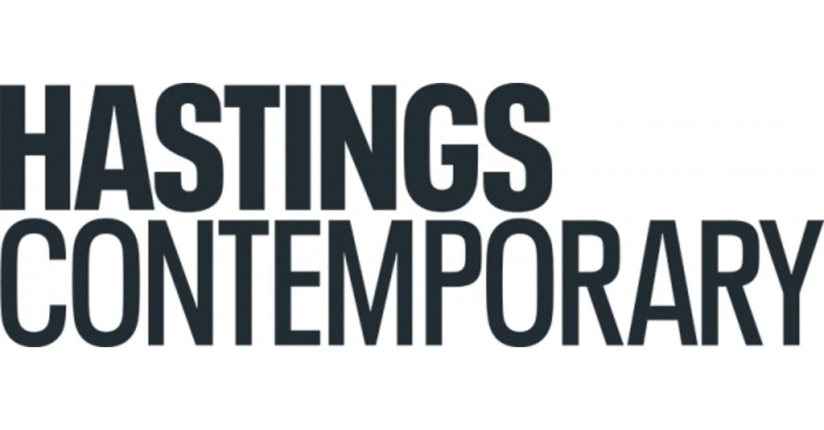
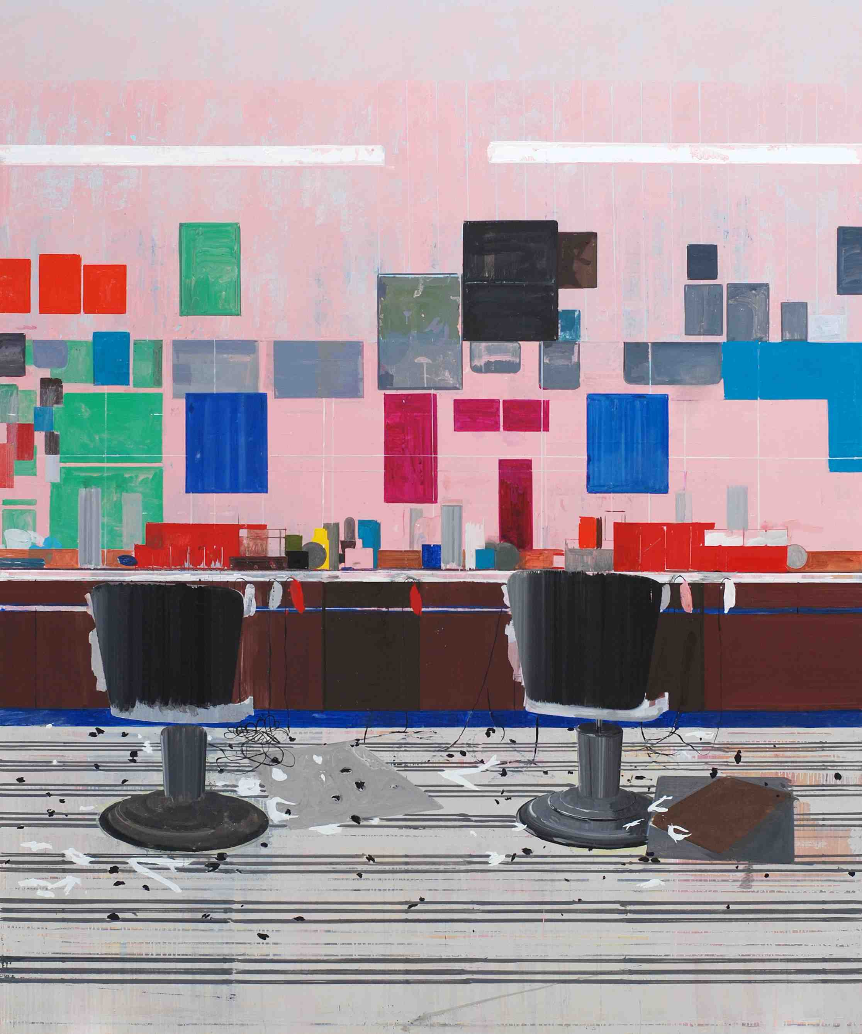

Hurvin Anderson: Salon Paintings
18 November 2023 – 3 March 2024
This autumn sees Hasting Contemporary proudly host a major review of Hurvin Anderson’s (b.1965) paintings and drawings, including examples of his very latest work.
The exhibition is presented in association with The Hepworth Wakefield and Kistefos Museum, Norway.
Salon Paintings will feature selected works from Anderson’s celebrated Barbershop series, which depict the interiors of traditional men’s hairdressers and evoke a profound sense of history, memory and place.
Although he has been making art for the past 25 years, Anderson first painted a barbershop scene in 2006, after a visit to a local barbershop. In an interview, he explained: “When I first saw the space, it was actually more about the mirrors. I walked in. It was quite still. Guys were waiting. People were cutting hair. Then you’d turn around 90 degrees and there’s two mirrors behind you. It’s an odd atmosphere to work in. To have so much reflection. To see yourself constantly.”
Anderson photographed the salon and used his images as the basis for what became a series of brightly coloured, semi-abstract works, featuring the typical paraphernalia of a barbershop, including the distinctive chairs, bottles, machines, large mirrors and posters. Indeed, the barbershop would become a recurring theme of his work, one which he has regularly visited for the past 15 years. The images he finds on barbershop walls also fascinate him: “Hairstyles, of course, but also football teams, newspaper articles. It gave another twist somehow.”
Among the key aspects – indeed pleasures – of visiting a hair salon, are the things that may be overheard, as Anderson notes: “A lot has been said about the conversations that go on in barbershops,” His incorporation of the posters on the barbershop walls provides another “way of bringing these conversations into the paintings.” Moreover, the colours and aesthetic of the salons provides their Caribbean customers with a connection back to their homelands.
The exhibition presents an opportunity to enjoy the most comprehensive presentation of the Barbershop series to date; from the very first painting and initial studio drawings made in 2006 to a new large-scale drawing and a painting begun in 2022, which are the largest and final works in the series. To give a tangible sense of his creative process, the exhibition will also include a display of Anderson’s sketches, drawings and studies.

Also on display will be some of Anderson's most political works, such as Is it OK to be Black? (2016), which includes depictions of two of the most significant figures in the American Civil Rights movement, Martin Luther King and Malcolm X. The title refers to a mis-hearing of the classic barber’s question, ‘Is it ok at the back?’.
Commenting on the exhibition, Hurvin Anderson said: “The Barbershop is a subject that I have returned to throughout my career, as a site that was a point of connection to Caribbean culture. In repeating the image, deconstructing it and putting it back together again, the series has also become a meditative exploration of painting itself.”
Liz Gilmore, Director of Hastings Contemporary said: “Turner Prize-nominated artist, Hurvin Anderson is one of the most prominent British painters working today and a great influence on the current generation of artists. The arrival of his Barbershop paintings in Hastings - an iconic series of work spanning almost 20 years of his practice – is hugely exciting for Hastings Contemporary, and so appropriate, given our position in the heart of the Old Town. The exhibition reflects our passion and commitment to showcasing the best of British art, both historic and contemporary. We are grateful to Hurvin for his generous insights and thinking in the development of this touring exhibition.”
A new book, edited by Eleanor Clayton and Isabella Maidment and published by The Hepworth Wakefield, will accompany the exhibition.
Hurvin Anderson: Salon Paintings is organised by The Hepworth Wakefield in collaboration with Hastings Contemporary and Kistefos Museum, Norway. Prior to its arrival at Hastings Contemporary from 18 November, the exhibition opened at The Hepworth Wakefield on 26 May 2023 and will next travel to Kistefos in Norway (April – October 2024).
Exhibition Partner
Exhibition supported by Ivor Braka Ltd, Richard and Debbi Burston, Clore Wyndham, Thomas Dane Gallery, Ryan Taylor Collection and Michael Werner Gallery.

NOTES FOR EDITORS
Hurvin Anderson, Flat Top, 2008. © Hurvin Anderson. Courtesy the artist and Thomas Dane Gallery. Photo: Hugh Kelly
HIGH RESOLUTION IMAGES FOR MEDIA USE CAN BE DOWNLOADED BY CLICKING ON THIS LINK
HURVIN ANDERSON was born in Birmingham in 1965 to Jamaican parents. He completed his BA at the Wimbledon School of Art in 1994, before receiving his MA from London's Royal College of Art in 1998. Anderson was shortlisted for the Turner Prize in 2017 and his work is represented in public collections around the UK, USA and Europe.

HASTINGS CONTEMPORARY champions modern and contemporary art. An ambitious programme of temporary exhibitions showcases work by important Modern British artists, internationally celebrated artists and emerging practitioners, often in Kunsthalle-style displays throughout the building. The gallery has developed a reputation for its focus on painting. Innovative programming, partnerships and collaborations support a commitment to outreach, learning and participation. The award-winning building is located on the town’s historic fishing beach among the net huts and working structures of the fishing fleet.

THE HEPWORTH WAKEFIELD was designed by the acclaimed David Chipperfield Architects and is set within Wakefield’s historic waterfront, overlooking the River Calder and The Hepworth Wakefield Garden, designed by Tom Stuart-Smith. Named after Barbara Hepworth, one of the most important artists of the 20th century who was born and brought up in Wakefield, the gallery presents major exhibitions of the best international modern and contemporary art. It is also home to Wakefield’s growing art collection – an inspiring resource comprising outstanding works of modern British and contemporary art. The gallery runs engaging programmes for schools, families and local community groups to provide inspiring creative learning opportunities and a vibrant workshop, talks and events programme, including regular art fairs and markets. hepworthwakefield.org

KISTEFOS was established in 1996 by Norwegian businessman and art collector Christen Sveaas on the former site of his grandfather’s pulp mill. Today, Kistefos offers world-class architecture, industrial history, art exhibitions, and an expansive sculpture park in scenic surroundings. Every year, Kistefos presents new art exhibitions by highly recognized national and international artists in its two galleries, The Twist and Nybruket Gallery. The Twist has won several prizes for its cutting-edge design and is a gallery, a bridge, and a sculpture, all in one. Nybruket Gallery is located in one of the old factory buildings of the wood pulp factory. The industrial heritage has been preserved and creates a beautiful framework for contemporary exhibitions. The sculpture park expands with one or more sculptures each year. Today there are 51 works by prominent contemporary artists such as Pierre Huyghe, Carol Bove, Ida Ekblad, Yayoi Kusama, John Gerrard, Claes Oldenburg, Lynda Benglis, Tony Cragg, Olafur Eliasson and Anish Kapoor. All recent sculptures are site-specific, inspired by the cultural heritage, nature and history of Kistefos. kistefosmuseum.com

For more information about Hastings Contemporary, visit www.hastingscontemporary.org / Twitter @_art_on_sea / Facebook ‘hastingscontemporary’ / Instagram @_art_on_sea

FOR MORE INFORMATION, INTERVIEWS, AND IMAGES
Tracy Jones, Brera PR – tracy@brera-london.com / 01702 216658 / 07887 514984 / www.brera-london.com

